International Institute of Professional Studies
Devi Ahilya Vishwa Vidhyalaya
Indore, M.P.


Project Report
On
Computerization
Of
KNBH - Hostel Management System

This Project is submitted for VI-semester
for degree of

Bachelor of Computer Application - 2009

Guided By : Submitted By :

Mr. Shaligram Prajapat Anviti Singh
IC-2K6-23

Kishore Joshi
IC-2K6-36

BONAFIDE CERTIFICATE

This is to certify that the project report entitled “KNBH-Hostel Management System” submitted to Devi Ahilya University in partial fulfillment of the requirement for the award of the degree of BACHELOR OF COMPUTER APPLICATION (BCA), is an authentic and original work carried out by Mr. Kishore Joshi (IC-2k6-36) and Ms. Anviti Singh (IC-2k6-23) under my guidance.
The matter embodied in this project is genuine work done by the student and has not been submitted whether to this University or to any other UNIVERSITY / Institute for the fulfillment of the requirements of any course of study.

Internal Examiner : External Examiner :

RECOMMENDATION

The Project wok entitled “Hostel Management System” submitted by Anviti Singh and Kishore Joshi is satisfactory account of the bona fide work under my supervision and is recommended towards the end of their III year of B.C.A. 2009.

Guided By :
Mr. Shaligram Prajapat

ACKNOWLEDGEMENT

We acknowledge our sincere thanks to those who have contributed significantly to this project. It is a pleasure to extend deep gratitude to our internal guide Mr. Shaligram Prajapat, IIPS, for his valuable guidance and support and to continuously prompt us for the progress of the project. We thank him for his valuable suggestions towards our project, which helped us in making this project more efficient and user friendly.

We thank and acknowledge each and every ones efforts that helped us in some or the other way for small and significant things.

ABSTRACT

The project aims at developing a completely Integrated Application designed to cater to every administrative requirement in the proper functioning of Hostel Management. It will be a tool for managing resources, gathering essential data, conversion of this data into information, and making the information available to right person at right time for informed decision making. This includes receiving specifications of student, confirmation of allotment and operating multiple entities without compromising on the integration of the application. Thus the project aims at improved service and consistent reviewing of status of the hostel information at any point of time.

TABLE OF CONTENTS

1. INTRODUCTION 1

  - The Client Organization 2
  - Problem definition 2
  - Aim 3
  - Objectives 3
  - Project Goals 3
  - Benefits 4
  - Methodology 5

2. CURRENT SYSTEM AND PROPOSED SYSTEM 8

  - Current system 9
  - Limitations of Current System 9
  - Proposed system 10
  - Objectives of Proposed System 12

3. FEASIBILITY STUDY 13

  - Feasibility Analysis 14
  - Economical Feasibility 14
  - Technical Feasibility 15
  - Behavioral Feasibility 18

4. ANALYSIS 19

4.1 Questionnaire 20
4.2 Statistical Analysis 20
4.3 Interview 20

5. PROJECT PLANNING 25

  - Project Scope 26
  - Document Plan 26
  - Team Structure 27
  - Project Deliverables 27
  - Gantt Chart 28

6. DESIGN 29

6.1 Logical Design 30
61.1 Entity Definition 30
6.1.2 Attribute Definition 31
6.1.3 Relationship 32
6.1.4 E-R Diagram 33
6.1.5 Data Flow Diagram 34
6.1.6 Flow Diagram 37
6.1.7 Use case Diagram 39
6.2 Physical Design 43
6.2.2 User Interface 47

7. IMPLEMENTATION 65

8. CODE SNIPPET 67

9. TESTING 106

9.1 Black box testing 107
9.2 White box testing 107
9.3 Unit testing 108
9.4 Integration testing 109
9.5 System testing 109

10. FUTURE PROSPECTIVE 110

12. BIBLIOGRAPHY 112

13. REFERENCES 112

- INTRODUCTION

1

INTRODUCTION

1.1 The Client Organization

Kamla Nehru Boys hostel manages the hostel for students of different courses in IIPS. It manages 40 rooms, divided in 2 wings A and B. It assigns a room to 2 students only. Fees payment is done through bank; bank receipt record is then maintained. It also has Store to issue and retrieve utilities. Guest record is also maintained in KNBH.

1.2 Problem Definition

The following points describe the problem domain at the client organization:-

- Non integration of all records of the hostel.

- Most of the bills are written on a paper and are sent to accounts department for final billing, which gives scope of human error.

- All the information in the system is maintained on the paper. This results in wastage of time and energy.

- Due to manual system, fine collection is not done timely.

- There is no Student Identification code.

- Records may have to be edited or re-entered adding to the cost.

- In case of leaving hostel, updation of records become complex, and check like, fees payment, is also complex.

1.3 Aim

To design and develop an Information System for Kamla Nehru Boys hostel, so as to make the task of management more efficient, speed and effective using the concepts of database design and following the steps of IT project management.

1.4. Objective

The objectives of the development are as follow:

- Integration of all records of hostel.

- Computerization of present paper system which results in economic use of time and cost.

- Validation on dates and calculation of number of semesters, student stay in hostel, results in proper fees collection.

- A student identification code is generated, so that the system can handle student as individual entity.

- Records editing, adding and updation is improved which results in proper resource management of mainly stores and guests.

- In case of leaving hostel, updation of record is made simpler and checks like fees payment is also made simpler.

- To increase efficiency of hostel.

1.5 Project Goals

- To build a prototype of HMS (Hostel Management Software).

- Reduce complexity of handling data.

- Implementing proper checks in every field.

- To provide an electronic version for management system.

- System will have a user friendly graphical interface and will be more cost effective as compared to non-electric version.

- Backup can be made on secondary memory like CD etc. .

1.6 Benefits

The various benefits that can be realized from this project are as follows:

- Easy maintenance of information
The proposed system maintains the details of the students required by the hostel. This proposed system will keep the track of the required information for student’s enrollment in the hostel. Thus, it helps user in efficient searching of information.

- No dependency on a specific person to get required information
System generates each student is allotted a Student ID in the format:-‘ course-course_year-room_no-(1/2)’

- Saves time and effort
It will keep in account the room allotment, that is, which room is allotted to which student. Room allotment is subdivided level of preference to course.

- Eases task of auditing
The proposed system will also keep track of information for the fees section, that is, whether the fees is paid by the student or not.

- Number of semester students stays in hostel, each semester fees will be taken.

- Guest information is maintained, and guest payment is also managed, guest fees:- 30 Rs per day.

- Stores issue utilities, whose record is maintained.

- Issued utilities are retrieved and fine is collected is deposited late, at Rs5 per day.

- It will also hold information of student regarding the warnings.

- The system will not allow any student to leave until his record is clear, like, fees paid, issued utility deposited, guest payment done.

- It also generates reports on useful information, like total fees deposited between any 2 dates, guest payment received, and list of issued utilities.

1.7 Methodology

The project plan is to carry the design and implementation of the project in a completely step-by-step manner. The entire project is divided in the following phases:-

Phase 1 – Study and Analysis Phase
- Questionnaire done to know the facilities and problem encountered by the student in hostel.(included in project report)
- Statistical analysis done on the basis of questionnaire. Some drawbacks were encountered from this section. (included in project report)
- Interview of Hostel warden, Mr. Ramesh Thakur, Ms. Pratibha taken. Present system functionalities, its problem were completely understood. Information regarding the project were taken.

Phase 2 - Design Phase
In this phase the database design of the system are made. The database design is being carried in the following steps-

- Identified the entities and their relationships from the scenario.

- Designed ER model for the proposed system and relation among these entities were noted down in form of tables, having fields as attributes. (included in project report)

- The logical model of the system is designed, normalizing the relations.

- Data flow diagram of the whole system is constructed. For proper information flow, each level DFD is prepared. (included in project report)
- Flow chart of each process of DFD is constructed for better flow of data and its verification. (included in project report)
- Proposed the physical design of the system.

- Defining hardware and software requirements.

Phase 3 - Coding Phase
- The design of the system is implemented through actual code.
- Proper validation of data is used.
- Proper validation on important fields provided.
- User does not need to have the knowledge of the code, output is defined user friendly.

Phase 4 – Testing and Implementation
Testing is done on various test cases and data set. Testing is applied on:-
- Testing on each form by taking different user cases.
- Updation of record when a fee is paid.
- Updation when utilities issued.
- Records are managed when student leave a hostel.
Testing is done by:-
Black box testing, White box testing and unit testing.

The above plan follows the Software Development Life Cycle (SDLC) model for the development of the proposed system. There are several ways for developing software. They consist of the following steps:
Preliminary Investigation - When a request to receive assistance from an information system is made, the first system activity, the preliminary investigation begins. It has three parts-

- Request clarification - All the request of the hostel system are met by clarifying each one with the warden.

- Feasibility analysis - An important outcome, The system is technically feasible, hostel budget is kept in mind, so economically supportive, and implementation is not so difficult, so operationally feasible.

- Request Approval - Not all requests are desirable or feasible. So the warden sir and authority decides which one are important and then we schedule them accordingly.

Determination of system requirements – We studied the Hostel process to answer the following questions:
  - What is being done for room allotment and how is it being done?
  - How frequently warden register complain occur?
  - How great is the volume of transactions (fees) or decisions (for complain authority)?
  - How well is the issue/return utility task being performed?
  - Does a problem occur in updation?
  - How serious is the problem of searching?
For this questionnaire and survey are done. Statistical results are also drawn from questionnaire; these all documents are attached in the project report.

Design of a system - It produces the details that state how the system will meet the requirements specified during systems analysis.
Design of report and output → Design of input data and form, and data to be stored → Calculation performed→ validation and verification code done→ testing.

2. CURRENT SYSTEM AND PROPOSED SYSTEM

2

CURRENT AND PROPOSED SYSTEM

2.1 Current System

The current system that is being used in the Kamla Nehru Boys Hostel is completely manual in nature. Information about various students is maintained separately in registers. The entries made in each and every register are having a serial number corresponding to the register name and year. These serial numbers are unique in nature for a particular register. The serial numbers are used for searching the records of various students. There are total of 8-10 registers, which are used to maintain details about various works of the hostel. These registers contain each and every information of student like student no., student name, address, course, fees paid, etc.

2.2 Limitations of Current System

The current system KNBH has a large number of limitations. These limitations encourage the improper maintenance of records. At the time of requirement gathering and analysis the following limitations are discovered

- A lot of information is duplicated into the registers, which proves as a waste of valuable time and effort.
- Since the system is manual there is scope of error due to carelessness and no manipulation.
- No backups of the records are maintained due to the tedious nature of the work. This might lead to loss of data in case of calamities like fires etc.
- Searching for particular records gets more and more difficult as the records get older.
- No use of identification code which leads to mismatch result.
- Calculation is done manually, like of collection fine, which may result in error.
- The manual system is not consistent in nature.
- In case of requirement of multiple copies of a document, duplications have to be made by hand.
- Since all record is on paper, loss of data can take place due to wear and tear over a period of time.
- Important reports and comparison charts cannot be generated on time due to cumbersome nature of task.
- Since there is a lot of repetition of information, which has to be done manually, there is no check for wrong replication of records.
- No recovery of data is possible by any means if it gets lost.
- To maintain all the records a large amount of money is required every year.
- It takes a lot of time for entering the data in to the registers manually.

2.3 Proposed System

The following points will give an overview of the proposed system :

- The proposed system is a completely automated system, which manages the entire operability of the firm.
- The system also generates appropriate reports by a particular student_id or between 2 dates and etc.
- The proposed system helps the user to retrieve the information as quickly as possible.
- The system provides backup plans to avoid data loss that is of high priority.
- It is Scalable so that in near future the system can be expanded and customized to the firm’s needs.
- The system is reliable enough to perform in adverse conditions.
- The system provides a user-friendly interface with a realistic view.
- The system provides an error free environment.
- The system is capable enough to reduce the number of registers i.e. system updates the data from one register to another by a single click.
- The system provides search facilities to find a specific entry from the database.
- The proposed system maintains the details of the students required by the hostel. This proposed system will keep the track of the required information for student’s enrollment in the hostel. Thus, it helps user in efficient searching of information.
- System generates each student is allotted a Student ID in the format:-‘ course-course_year-room_no-(1/2)’
- It will keep in account the room allotment, that is, which room is allotted to which student. Room allotment is subdivided level of preference to course.
- Proposed system will also keep track of information for the fees section, that is, whether the fee is paid by the student or not.
- Number of semester students stays in hostel, each semester fees will be taken.
- Guest information is maintained, and guest payment is also managed, guest fees:- 30 Rs per day.
- Stores issue utilities, whose record is maintained.
- Issued utilities are retrieved and fine is collected is deposited late, at Rs5 per day.
- It will also hold information of student regarding the warnings.
- The system will not allow any student to leave until his record is clear, like, fees paid, issued utility deposited, guest payment done.

2.4 Objectives of Proposed System

The aim of the proposed system is to address the limitations of the current system. Following are the objectives of the proposed system:

- Reduce data duplication.
- Implement validation techniques and checks that will help reduce the margin of error in operations.
- Provides adequate data backup facilities in order to ensure system restart even after a calamity.
- Since the system is VB based, searching and cataloging of data is not a problem.
- The system ensures consistency.
- Should arrive at and obtain a complete automation of all the registers as well as the registers, which are used for smooth working of the firm
- The system is a reusable and extensible model/code.
- The system is a foolproof system that simulates and replaces the present manual system.

3. FEASIBILITY STUDY

FEASIBILITY STUDY
3

3.1 Feasibility Analysis

Feasibility study examines how beneficial is the project economically, technically and non- technically. The KNBHMS is a truly feasible project and satisfies all the three conditions described below.

3.2 Economic Feasibility

The economic analysis of the project counts for the cost effectiveness of the project.

The economic feasibility of KNBH is measured under the following heads:

- The project fits in the proposed budget.
- The project satisfies the economic constraints.
- The existing hardware meets the budget proposed.

This project can be regarded as economically feasible because the hostel possesses the computer with them, so there is no need of bearing any cost on the resources needed for the development of the system. The only cost involved in the project is the installation cost. The only resource required for proper and successful installation is a computer system meeting software and hardware requirements of the system. These costs are quite minimal and easily available with the organization. In addition, there are no start-up costs for communications equipment installations, recruitment of new personnel, cost of disruption to the rest of the system.

3.3 Technical Feasibility :

The criteria for technical feasibility of KNBHMS are:

- Easy to use : The users were assumed to be normal ordinary people having knowledge of simple computer operation, so ease of use is a very essential factor if we want to get the job actually done quickly.

- Security: As login name and passwords are used at login time so security is maintained. Some functions are to be kept under control of some specific authority so password protected entry is used.

- Binary Compatibility: Our software makes it possible to extend an existing class or interface by adding new methods and properties and yet still retain binary compatibility.

- Reliability: As tables are used for storing the data, so reliability is maintained as exact data is retrieved. Data is regained from each table by using a unique key so the accurate record is accessed.

- Maintainability :Maintenance usually comprises of 2 key factors:-

  - Updation :-
As the project is build with keeping in mind all the necessary functions so no essential updation is required. VB can be updated so that new layouts of data reports can be produced as desired.

  - Terminals must be updated with antivirus so the proper functioning of operating system can be maintained.

- Portability: As the size of project code is enormous. So a CD can be used to transfer it from one server to other. If required then data can also be moved using secondary memory devices. So it is portable to a large extent.

- Extensibility: The project is easily extensible as VB support further editing, such as adding new functions, new forms or editing old forms.

- Reusability: The extensibility and portability of this project would make it reusable software.

- Serviceability: This project will try to provide maximum possible service to the user.

In our project the technical feasibility is considered up to a great extend. The software is build using Visual Basic, which is freely available. Thus the problem of non- availability of software is eradicates. The backend of the system is MS Access, which is freeware database application. Proposed system can be expanded in future if required. Proposed system has the capacity to hold the data of the firm.
It also provides the data security by password protecting.

Technology

Microsoft Access 2003

Microsoft Office Access, is a relational database management system from Microsoft that combines the relational Microsoft Jet Database Engine with a graphical user interface and software development tools.
Access stores data in its own format based on the Access Jet Database Engine. It can also import or link directly to data stored in other Access databases, Excel, ODBC-compliant data container including Microsoft SQL Server, Oracle. It will use the file extension “.mdb”.
Key features :-
- Users can easily create tables, queries, forms and reports, and connect them together with macros.
- A significant strength of Microsoft Access is its Jet Database format (MDB) which can contain the application and data in one file.
- Microsoft Access also offers the ability for programmers to create solutions.
- Access offers the ability to import and export data to many formats.
- Microsoft Access offers a database password. Once entered, the user has full control of all the database objects.

Visual Basic 6
Visual Basic (VB) is a event-driven programming language and integrated development environment (IDE) from Microsoft for its COM programming model. VB is a programming language that uses a graphical development features and BASIC heritage. Visual Basic was derived from BASIC and enables the rapid application development (RAD) of graphical user interface (GUI) applications, access to databases using Data Access Objects, Remote Data Objects, or ActiveX Data Objects(ADO), and creation of ActiveX controls and objects.
ADO gives developers a powerful, logical object model for programmatically accessing, editing, and updating data from a wide variety of data sources through OLE DB system interfaces. The most common usage of ADO is to query a table or tables in a relational database, retrieve and display the results in an application, and perhaps let users make and save changes to the data. Other tasks include the following:
- Querying a database using SQL and displaying the results.
- Allowing a user to review and change data in database tables.
- Executing stored procedures.
- Dynamically creating a flexible structure, which is named a Recordset, to hold, navigate, and manipulate data.
- Performing transactional database operations.
- Filtering and sorting local copies of database information based on run-time criteria.
- Creating and manipulating hierarchical results from databases.
- Binding database fields to data-aware components.
3.4 Behavioral Feasibility :

Behavioral feasibility of KNBH is the measure that how effective the client uses the system. It is one of the major factors of feasibility analysis. The new and the proposed system-HMS(hostel management software) is

  - Easy to operate,
  - Convenient in maintenance and
  - Effective in its work.

Thus behavioral feasibility is very important factor to be considered for effective working of system.. The systems analyst must still consider the behavioral feasibility of the requested HMS. It is dependent on the human resources available for the HMS (Warden, Attendant, etc.) and involves projecting the system operates and be used when installed. The system is behaviorally feasible if it fulfills the following points :

- The HMS is easy to operate.
- In all the areas of application the expanded results are better than the earlier.
- Individual performance is not expected to deteriorate after implementation.
- Retrieval of information is easy, accurate and fast.

4. ANALYSIS

4

ANALYSIS

Study and Analysis

4.1 Questionnaire
Questionnaire done to know:-
- Problem encountered by the student will admission.
- The facilities provided in his daily routine.
- Action taken or handled if he makes any complain.
4.2 Statistical analysis
Statistical analysis done on the basis of questionnaire to know:-
- Many drawbacks of present system came into light.
- Fields to be included like, guest, complain, were encountered.
- New fields were included like stores.
- Response time on any complain registered.
4.3 Interview
Interview of Hostel warden, Mr. Ramesh Thakur, Ms. Pratibha taken, to know:-
- Present system functionalities were completely understood.
- Steps of action taken when a student make any complain.
- Action taken by warden sir against a student, here Warden Register came in to light.
- Room cycle, i.e., if any student leaves hostel.
- Information regarding the project was taken.
Questionnaire

Q.1) Is the admission process tedious? Yes No

Q.2) After the admission the room is allotted in how many days? _______________

Q.3) The table, chair and bed allotted in how many days? ______________________

Q.4) If any complaint is made about the room’s maintenance (like bulb replacement, switch board) how much time to repair it or replace it? ________________________

Q.5) During hostel life, have u been ill ever? Yes No
If yes then what support was given by hostel authority? ____________________

Q.6) In how many days toilets are cleaned? _________________________________

Q.7) If the water purifier is not working. How much time is taken to repair it? __________

Q.8) How many guest are allowed to stay in room? 1 2 more
For how long? ____________

Q.9) Proper security is maintained or not (like for personal vehicles)? Yes No

Q.10) Did the mess provide food on time? Yes No

Q.11) The food provided is healthy, nutritious? Yes No

Q.12) Did any record is kept and maintained of the visitors? Yes No

Q.13) If you are going home. Did u inform the hostel authority? Yes No
How much duration is allowed? ____________________
Q.14) At the time of power cut how things are managed, especially at night?
Statistical Results of BOYS Hostel

Total forms:-40
Q.1) Is the admission process tedious?

YES:- 22 (55%)
NO:- 18 (45% )

Q.2) After the admission the room is allotted in how many days?

Less than 5:- 24 (60%)
More than 5:- 16 (40%)

Q.3) The table, chair and bed allotted in how many days?

Same day:- 32 (80%)
More than 2 days :- 8 (20%)

Q.4) If any complaint is made about the room’s maintenance (like bulb replacement, switch board) how much time to repair it or replace it?
With in 2-5 days:- 26 (65%)
More than a week :- 14 (35%)

Q.5) During hostel life, have u been ill ever?
YES:- 16 (40%)
NO:- 24 (60% )

If yes then what support was given by hostel authority?
Majority:- NO SUPPORT
Seniors supported:- 9

Q.6) In how many days toilets are cleaned?

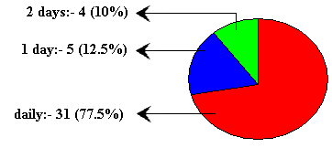

Q.7) If the water purifier is not working. How much time is taken to repair it?

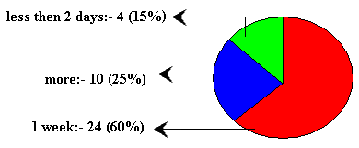

Q.8) How many guest are allowed to stay in room?
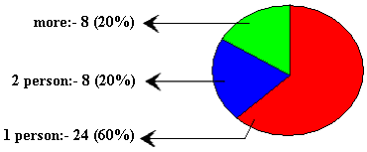
For how long?
5 days:- 8 (20%)
more than 5days:- 13 (32.5%)
Charges are their:- 4 (10%)
No answer:- 15 (37.5%)
Q.9) Proper security is maintained or not (like for personal vehicles)?
YES:- 33 (82.5%)
NO:- 7 (17.5% )

Q.10) Did the mess provide food on time?

YES:- 13 (32.5%)
NO:- 27 (67.5%)

Q.11) The food provided is healthy, nutritious?

YES:- 10 (25%)
NO:- 30 (75% )

Q.12) Did any record is kept and maintained of the visitors?

YES:- 35 (87.5%)
NO:- 5 (12.5% )

Q.13) If you are going home. Did u inform the hostel authority?

YES:- 8 (20%)
NO:- 32 (80%)

How much duration is allowed?

Majority:- As per our will

Q.14) At the time of power cut how things are managed, especially at night?

Candle:- 18 (45%)
Invertors:- 0 (0%)
No arrangement:- 22 (55%)

5. PROJECT PLANNING

5

PROJECT PLANNING

The most critical phase of managing system projects is planning. Information systems have become increasingly important during the past decade. First, information is now recognized as a vital resource. Second, more and more financial resources are committed to information systems. Third, there is growing need for formal long-range planning with Information systems.

5.1 Project Scope

The scope of the project can be described in the following manner:

Designing a mechanism which can act as a platform for user to efficiently and easily design timetable.

Designing a user friendly graphical user interface to enter teacher, class and subject information.

To develop a report to print timetables designed by the user.

5.2 Development Plan

The design and implementation of this project has been carried out in a completely step-by-step manner.
- Questionnaire
- Survey
- Design Document
- Software Requirement Specification
- Coding
- Testing
- Project Report

5.3 Team Structure

Kamla Nehru Boy’s Hostel
(Project)
Software Developer
(Anviti Singh)
(Kishore Joshi)
Internal Guide
(Mr. Shaligram Prajapat)

5.4 Project Deliverables

Project Report
Project report provides an introduction to current system and system to be built. It gives the brief knowledge of current system

Project Documentation
A complete documentation is given in the form of SRS. Software Requirement Specification (SRS) it provided an introduction of the current system and the system to be built. This overview includes the purpose of SRS and a brief knowledge of the current system. The overview also provided an introduction of the proposed system.

Pre- Installation
The installation of prior software’s like Microsoft Access. These software are essential for the smooth and proper running of project.
5.5 Gantt chart

Gantt chart is a time-phased bar chart display that lists tasks or activities along the left side and a corresponding bar for each task. The length of the bar represents the duration of the activity. This scheduling tool used to display the status of a project’s tasks. The Gantt chart shows each task’s duration as a horizontal line. The ends of the lines correspond to the task’s start and end dates.

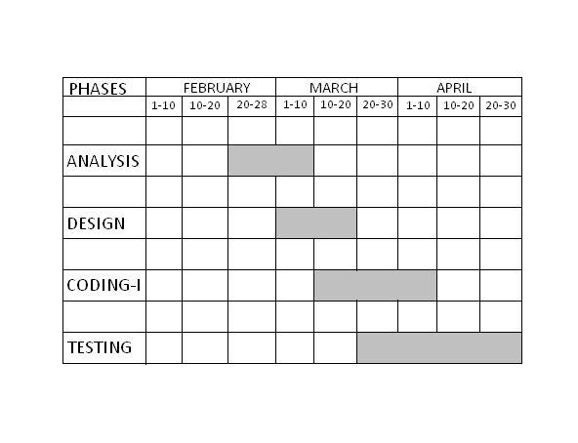

6. DESIGN

6

DESIGN

6.1 Logical Design

Logical design describes the functions required of a system, those are:-

- Student admission
- Room allotment
- Fees payment
- Guest payment/stays with
- Utilities issue/retrieval
- Complain management
- Warden register

The following are the objectives of Logical Design :

- Analyze transaction of fees, forms, and displays required by the hostel room allotment functions.

- The ER Diagrams constructed by keeping in my general entries related to student and relation with other entities.

- Transformation of Conceptual Data Model into a Relational Model with data specifications.

6.1.1 Entities Definitions

Entities are the principal data object about which information is to be collected. Entities are either concrete or abstract, such as person, places, things, or events, which have relevance to the database.
The following is the list of entities that have been identified during analysis:-

- Name: Student
Definition: there can be large number of students
Identifier: student_id

- Name: Room
Definition: we have 40 rooms, wings A and B
Identifier: room_no

- Name: Student Fees
Definition: each semester from date of registration
Identifier: receipt_no

- Name: Utilities
Definition: fixed number of each utility
Identifier: utility_name

- Name: Student Guest
Definition: guest of a student
Identifier: guest_name

6.1.2 Attribute Definitions

The attributes that are identified as part of the entities are listed along with their description.

1. Name of Entity: Student

Attribute | Datatype | Description | Length | Allow null
student_id | text | Id generated by system | 50 | no
name | text | Student name | 50 | no
address | text | Student address | 100 | no
Phone_no | number | Student phone no | double | no
course | text | Institute course | 50 | no
course_yr | number | Admission yr of course | long | no
Registration-date | date | Registration date at hostel |  | no
Date_of_birth | date | Date of birth |  | no

2. Name of Entity: Room

Attribute | Datatype | Description | Length | Allow null
room_no | text | Room number | 50 | no
first_id | text | Student_id who is I in room | 50 | yes
second_id | text | Student_id who is II in room | 50 | yes
vacancy | number | Vacancy in the room 0/1/2 | long | no

3. Name of Entity: Student fee

Attribute | Datatype | Description | Length | Allow null
student_id | text | Id who is paying fees | 50 | no
receipt_no | number | Receipt no of bank | long | no
amount | number | Amount paid in bank | long | no
date | date | Date of receipt |  | no
semester | text | Jan-june or july-dec and year | 50 | no

4. Name of Entity: Utilities

Attribute | Datatype | Description | Length | Allow null
Utility name | name | Name of utility | 50 | no
quantity | number | Quantity presently available | long | no

5. Name of Entity: student guest

Attribute | Datatype | Description | Length | Allow null
student_id | text | Id who’s guest is their | 50 | no
Guest_name | text | Guest name | 50 | No
date | date | Date guest arrived |  | no
days | number | No. of days he will stay | long | no

6.1.3 Relationships

Binary relationship
One to one:-
Student < - > room

One too many:-
Student < - > utilities
Student < - > Fees
Student < - > Guest
Student < - > complain
Warden < - > student

Weak entity:-
Guest is a weak entity of student and room.

6.1.4 The entire E-R Diagram

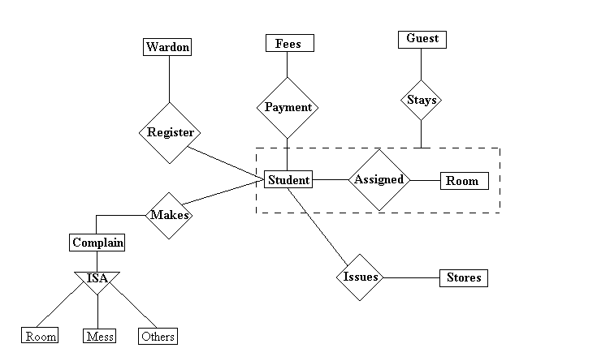

6.1.5 Data Flow Diagram
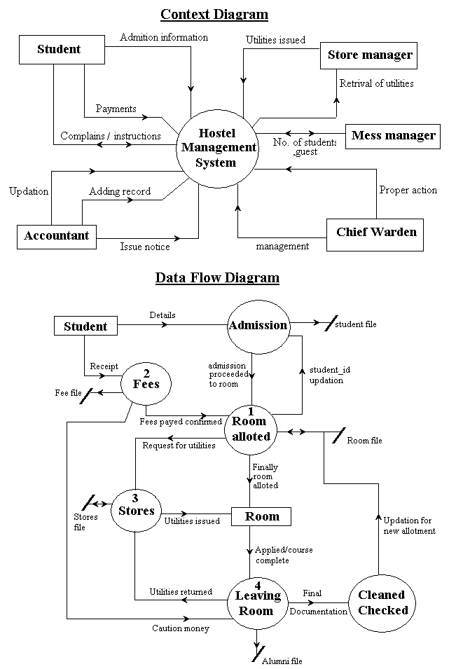
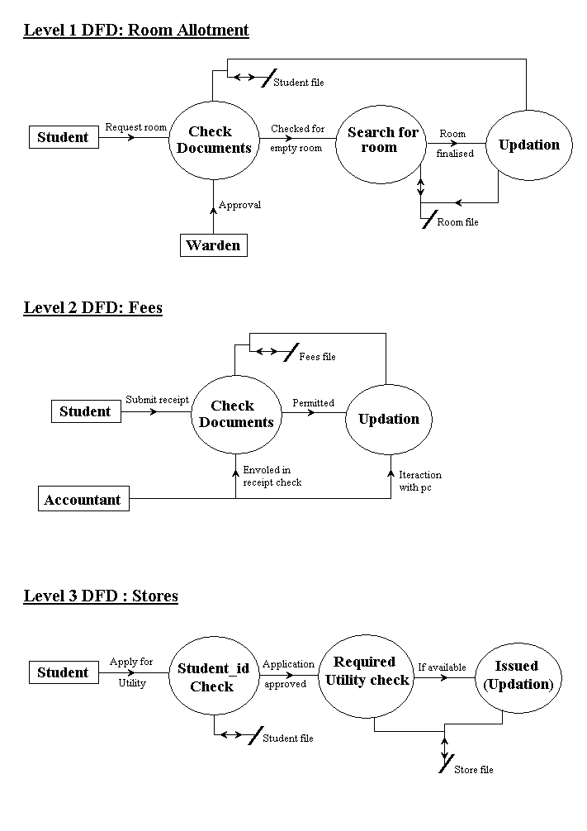

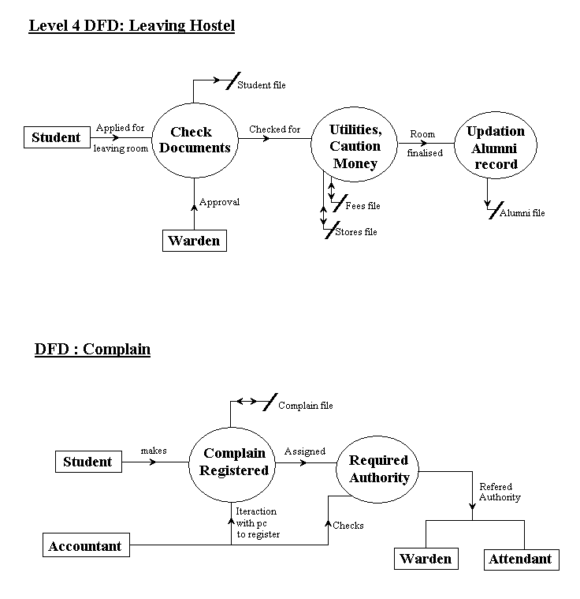

6.1.6 Flow Diagram

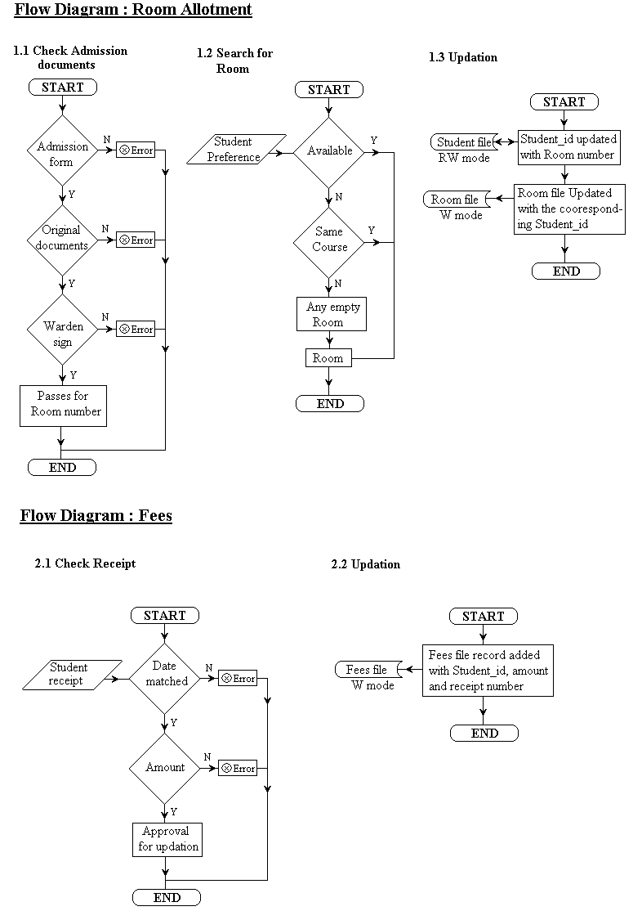

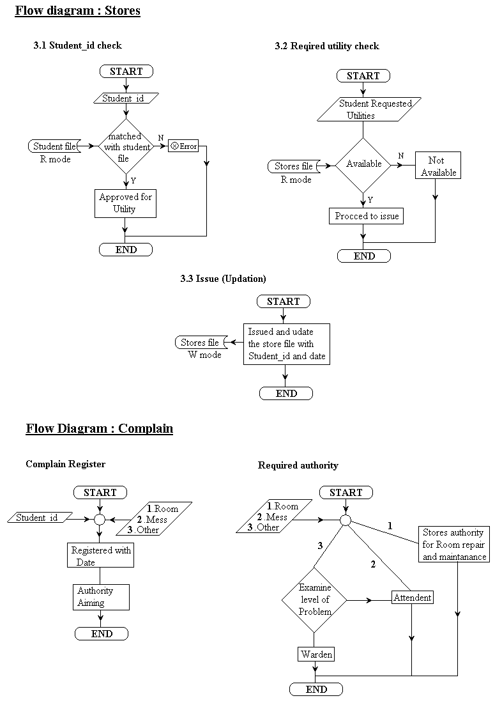

6.1.7 Use case Diagrams

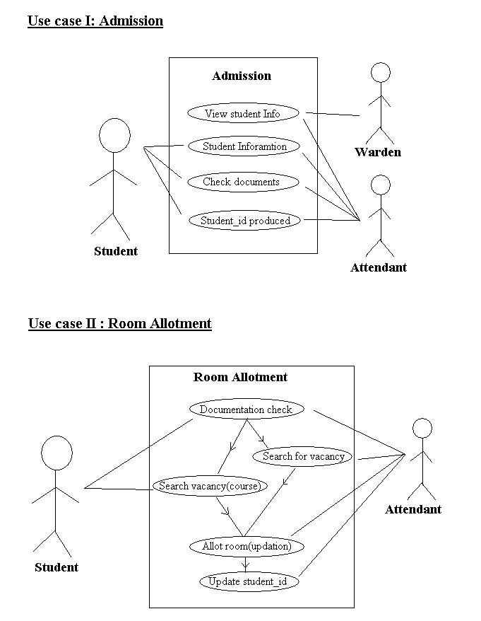

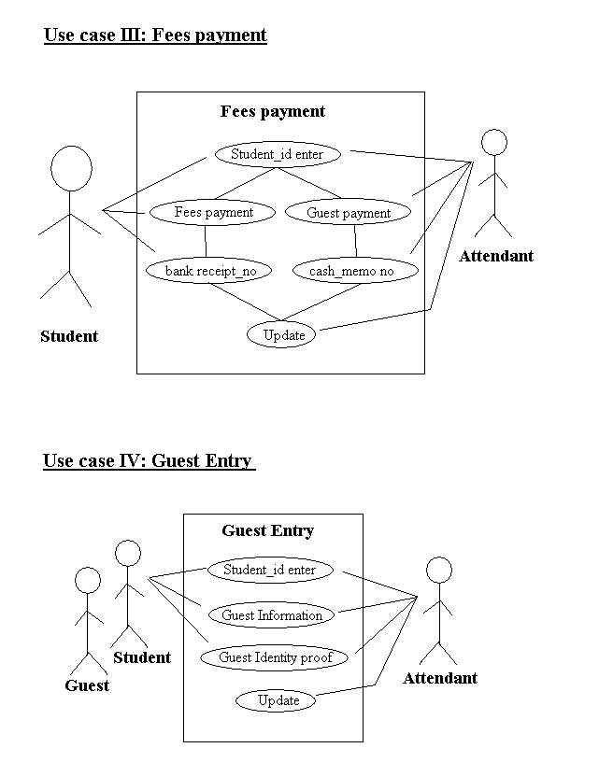

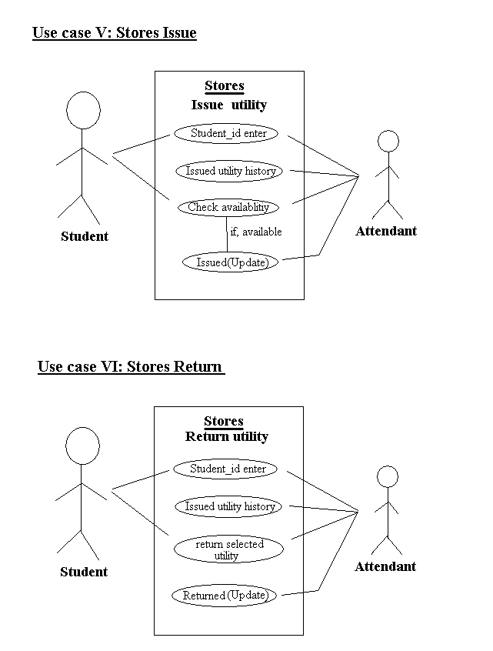

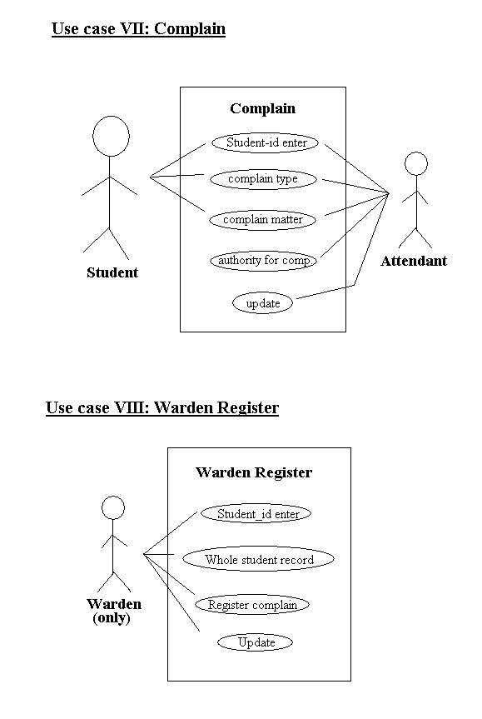
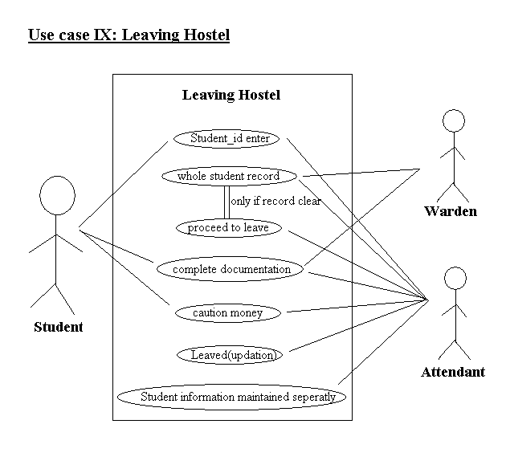

6.2 Physical Design

- We have 11 tables at designed for storage.
- Normalized relations, to get database which can be stored on secondary memory.
- Tables are used for: - Entered, Retrieved, Deleted and Updated
- The point of response time:- Data security, Backup, Recovery, Retention and Integrity; are kept in mind.
- Backend files are also password protected.

The table design of our Physical Database:-
1. student_info

Attribute | Datatype | Length | Allow null | Default
student_id | text | 50 | no
name | text | 50 | no
address | text | 100 | no
Phone_no | number | double | no | 0
course | text | 50 | no
course_yr | number | long | no
Registration-date | date |  | no
Date_of_birth | date |  | no

2. room

Attribute | Datatype | Length | Allow null | Default
room_no | text | 50 | no
first_id | text | 50 | yes | NA
second_id | text | 50 | yes | NA
vacancy | number | long | no | 0

3. student_fees

Attribute | Datatype | Length | Allow null | Default
student_id | text | 50 | no
receipt_no | number | long | no | 0
amount | number | long | no | 0
date | date |  | no
semester | text | 50 | no

4. utilities_list

Attribute | Datatype | Length | Allow null | Default
Utility name | name | 50 | no
quantity | number | long | no | 0

5. guest_payment

Attribute | Datatype | Length | Allow null | Default
student_id | text | 50 | no
Guest_name | text | 50 | no
Address | text | 50 | no
Phone | number | double | no | 0
Date_of _stay | date |  | no
Identity | text | 50 | no
Amount | number | Long |  | 0
Cash_memo | number | long |  | 0
Date_of_payment | date
days | number | long | no | 0

6. issue_utility
Attribute | Datatype | Length | Allow null | Default
Student_id | text | 50 | no
Utility name | name | 50 | no
Date_of_issue | date |  | no
days | number | long | no | 0
Date_of_return | date |  | no

7. leave_hostel

Attribute | Datatype | Length | Allow null | Default
Name | text | 50 | no
address | text | 100 | no
Phone_no | number | double | no | 0
course | text | 50 | no
course_yr | number | long | no
Registration-date | date |  | no
Date_of_birth | date |  | no
Leave_date | date |  | no
Fee_receipt | text | 255 | no
Guest_payment | text | 255
Caution_money | text | 50 | no
Room_no | text | 50 | no
8. utility fine

Attribute | Datatype | Length | Allow null | Default
Student_id | text | 50 | no
Cash_memo | number | long |  | 0
Amount | number | Long |  | 0
date | date |  | no

9. student_complain

Attribute | Datatype | Length | Allow null | Default
Student_id | text | 50 | no
Complain_type | text | 50 | no
Complain_text | Text | 50 | no
date | date |  | no
authority | Text | 50 | no
urgency | text | 50 | no

10. Warden Register

Attribute | Datatype | Length | Allow null | Default
Student_id | text | 50 | no
Complain_text | Text | 50 | no
date | date |  | no
Police_report | text | 50 | no

11. council_member

Attribute | Datatype | Length | Allow null | Default
Event_secretary | text | 50 | no
Student_council | text | 50 | no
Spoert_incharge | text | 50 | no
Disciple_secretary | text | 50 | no
I floor incharge | text | 50 | no
II floor incharge | text | 50 | no
III floor incharge | text | 50 | no
IV floor incharge | text | 50 | no

6.2.2 User Interface Design

Visual Basic is used as the user interface, covering the points:-

  - Proper checks generated where field can not be left empty, like name, course, course year.
  - Student ID is generated by system so eliminating confusion, like same name.
  - Each form is student ID driven so no foreign excess.
  - Extra protection for field provided, like no name can have special characters, and no number field can have other than numbers.
  - Room allotment is also password protected.
  - Warden register is also password protected for warden sir only.
  - At the time of admission date can not be earlier one than today.
  - Dates are entered by default at many forms eliminating human errors.
  - Fine calculation is late by date is calculated by system, so no errors.
  - Form run in a flow of data so not difficult to understand.
  - All events are click driven so not complex.
  - Reports are generated in printable form is needed.
User interface forms can be seen next page:-

Interfaces

Admission

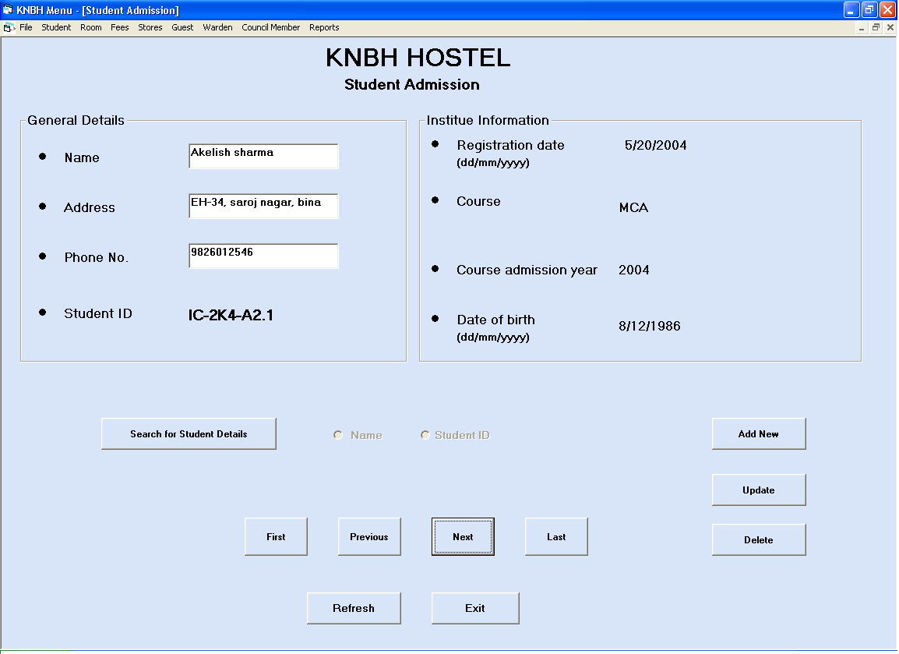

Room Part 1

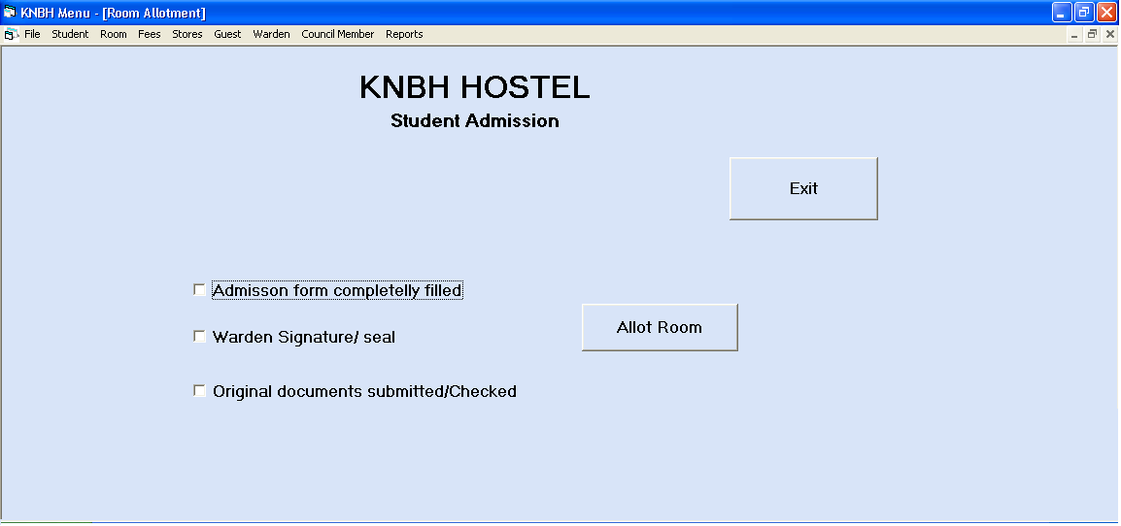

Room part 2.1

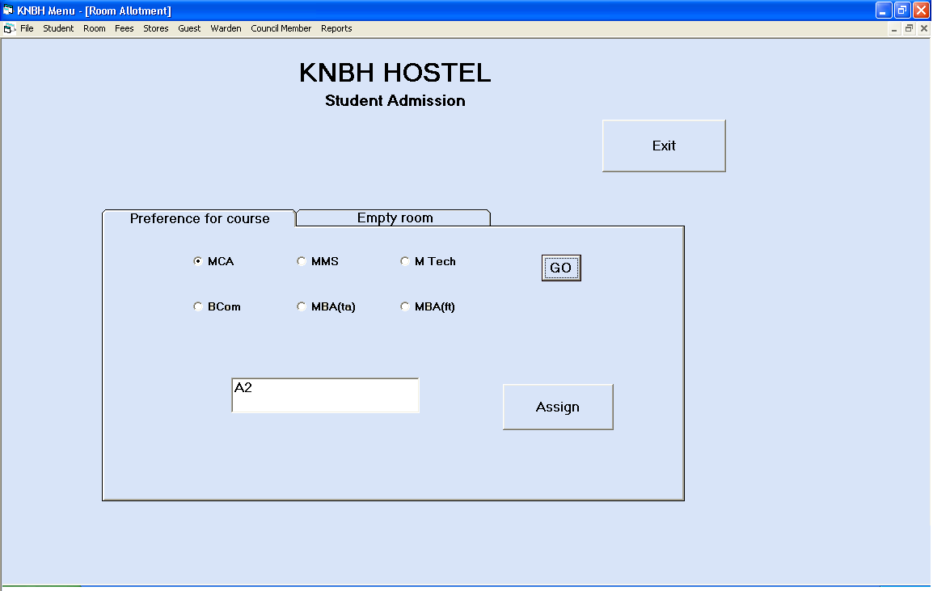

Room part 2.1
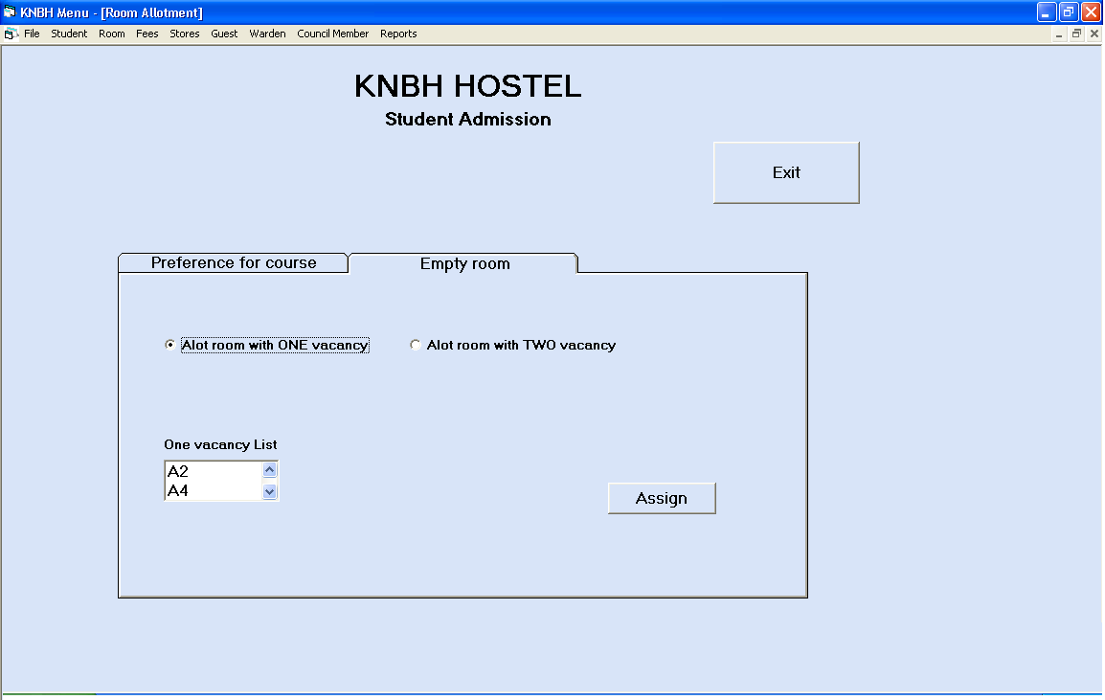

Room Part 3:- Final allotment
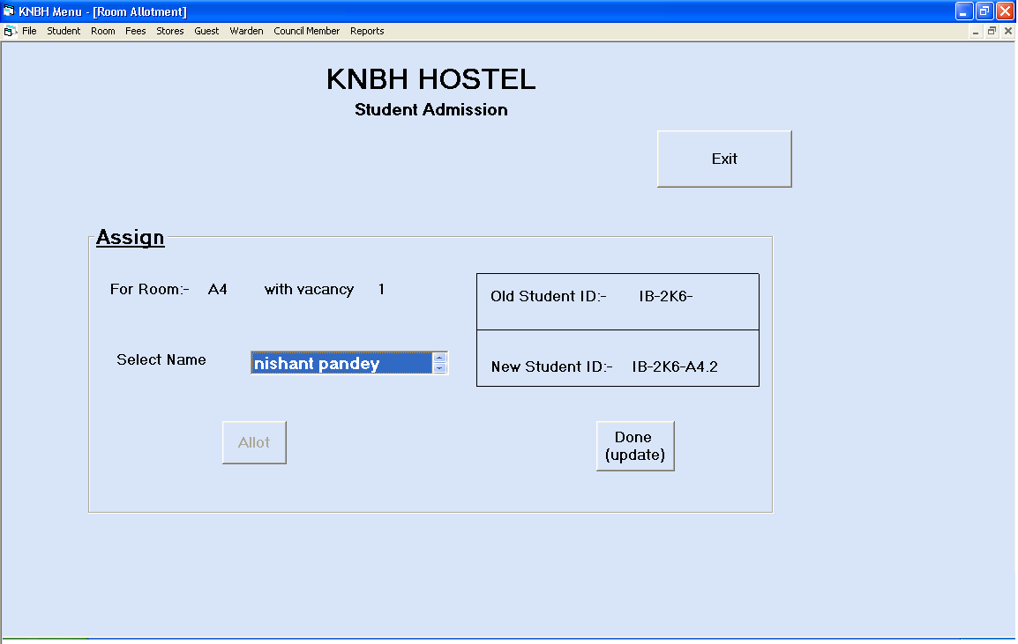

Fees Payment (semester)

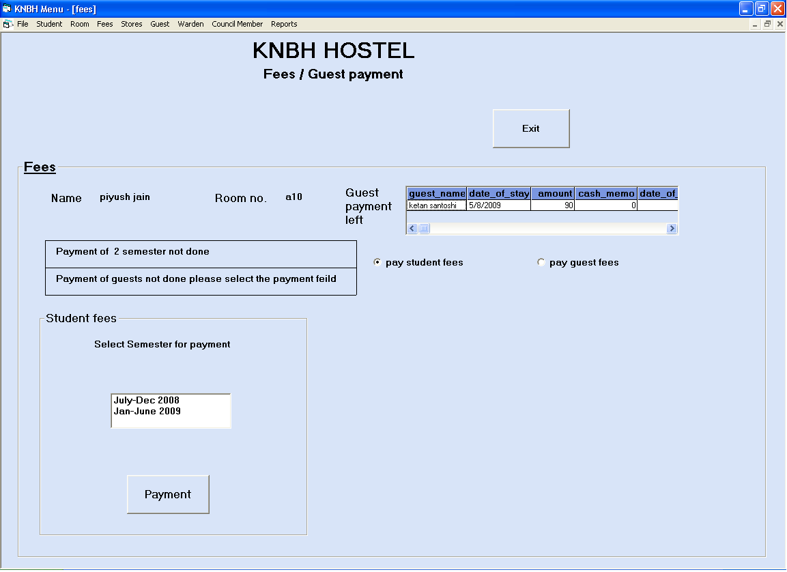

Fees payment of Guest

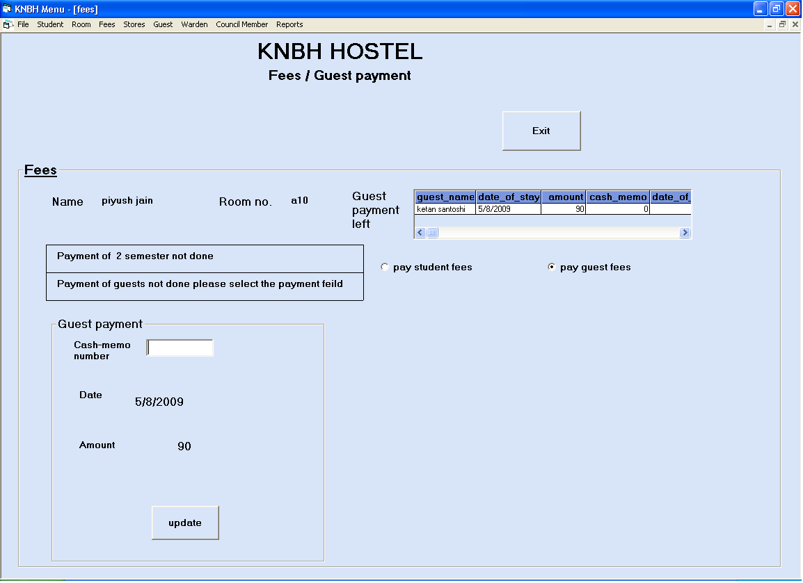

Guest Entry

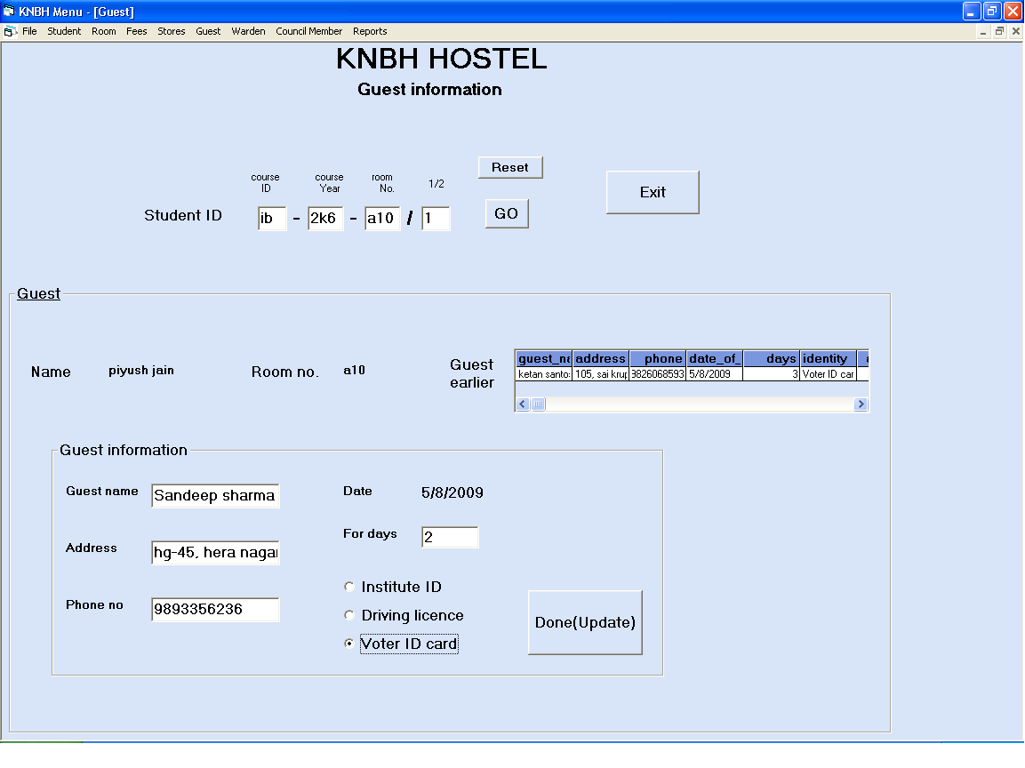

Issue Utility Part 1

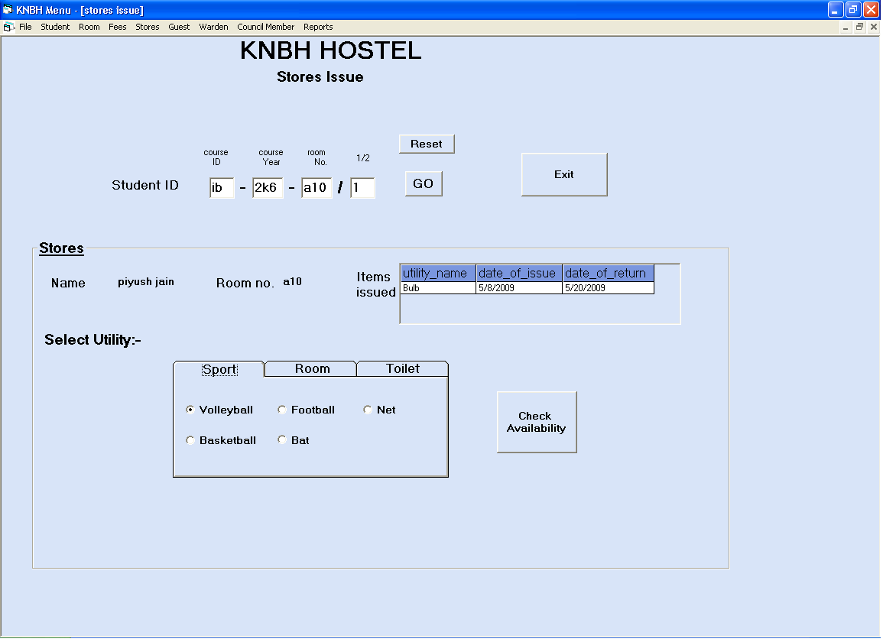

Issue Utility Part 2

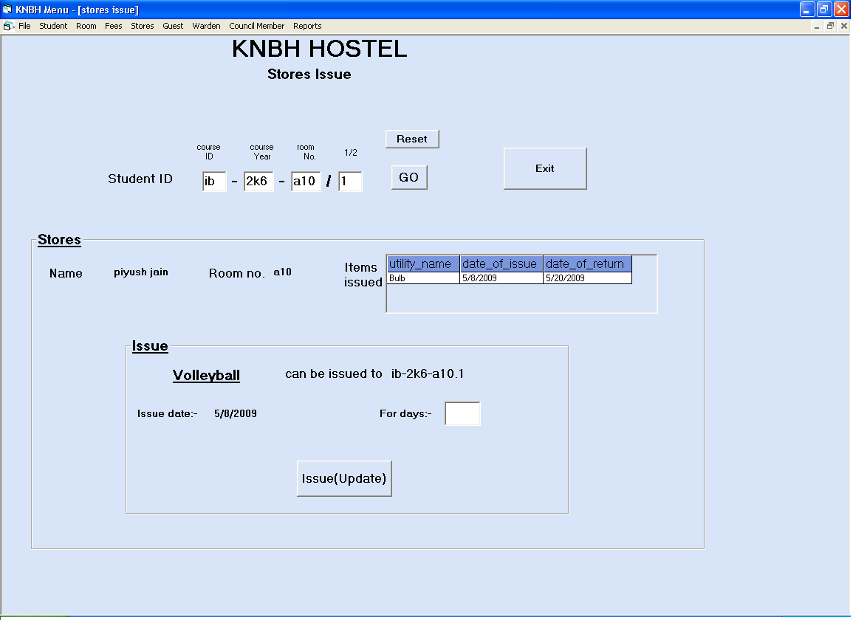

Return Utility Part1

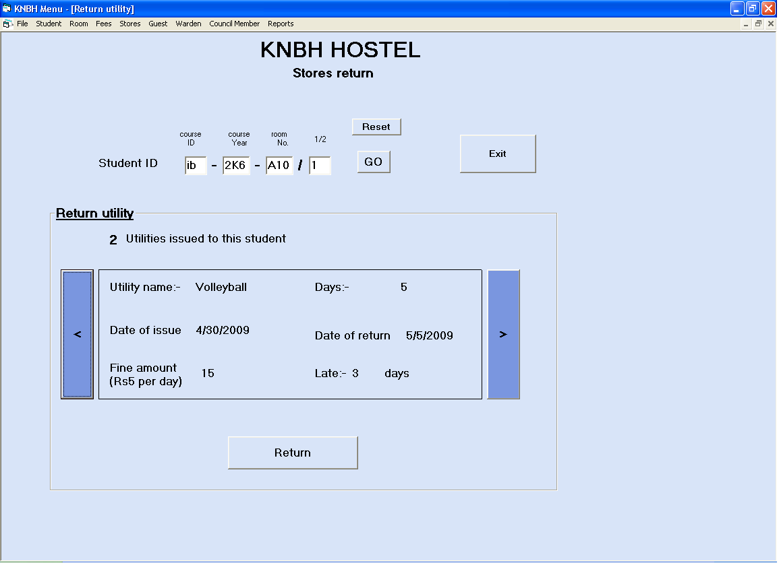

Warden Register Part 1

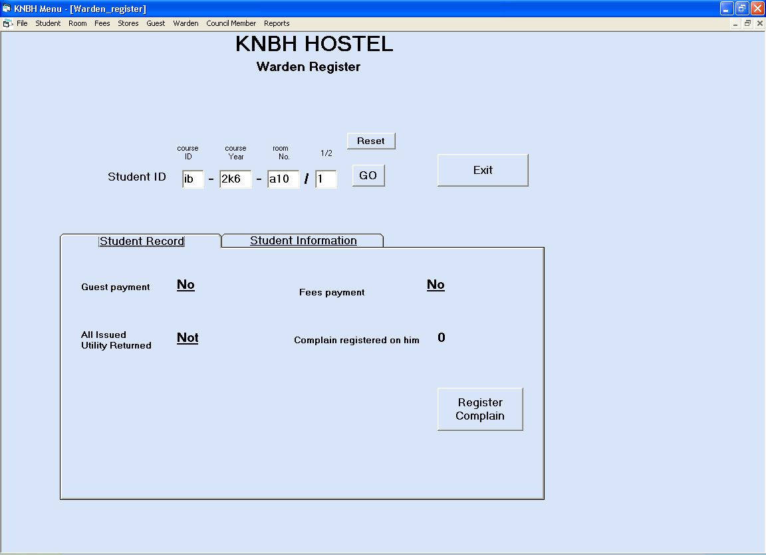

Warden Register Part 1

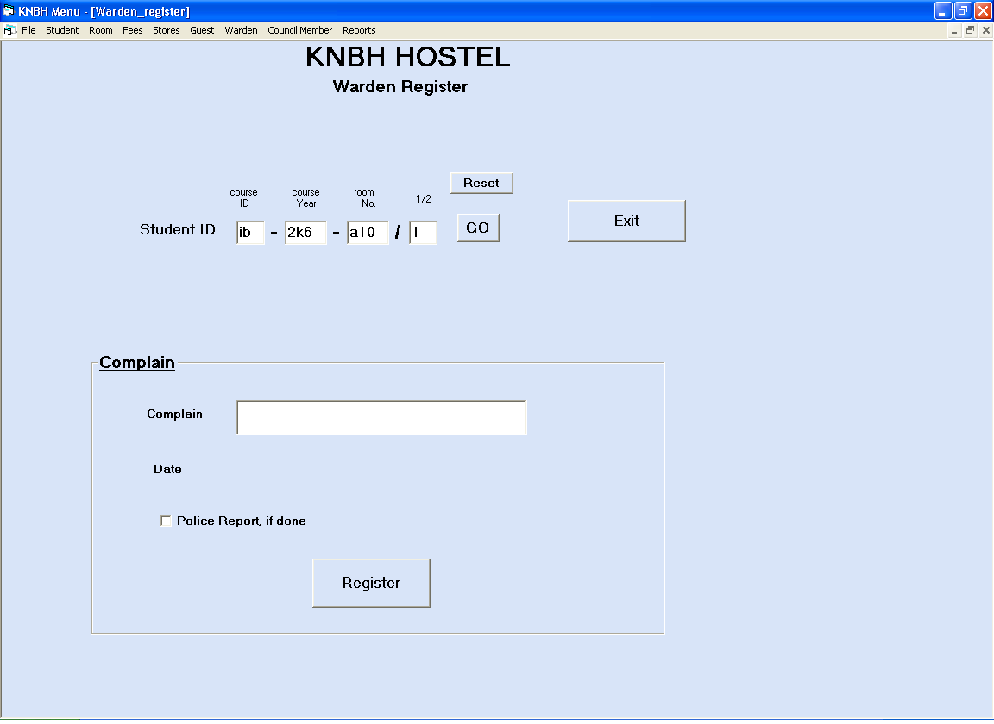

Complain

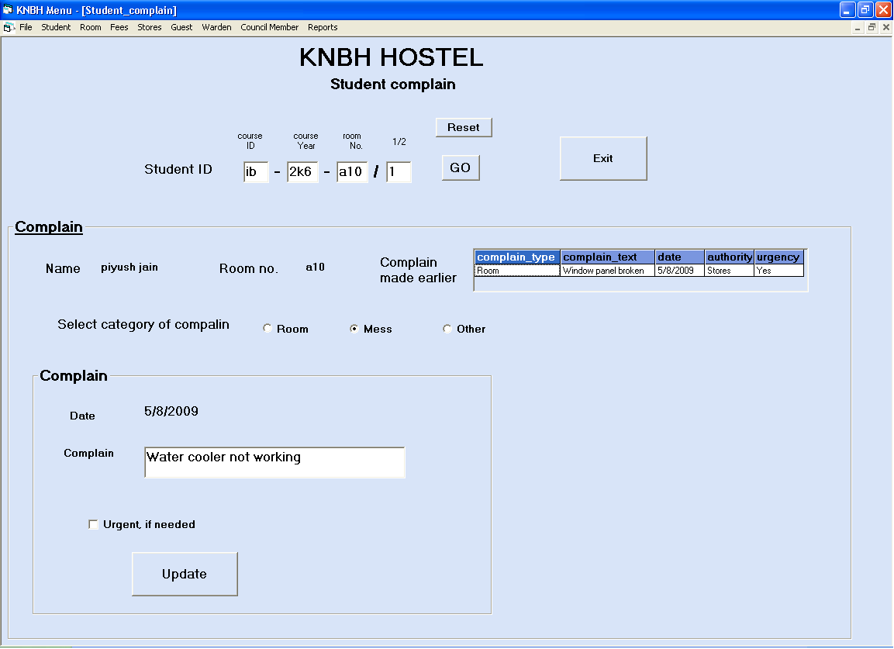

Council Member Part 1

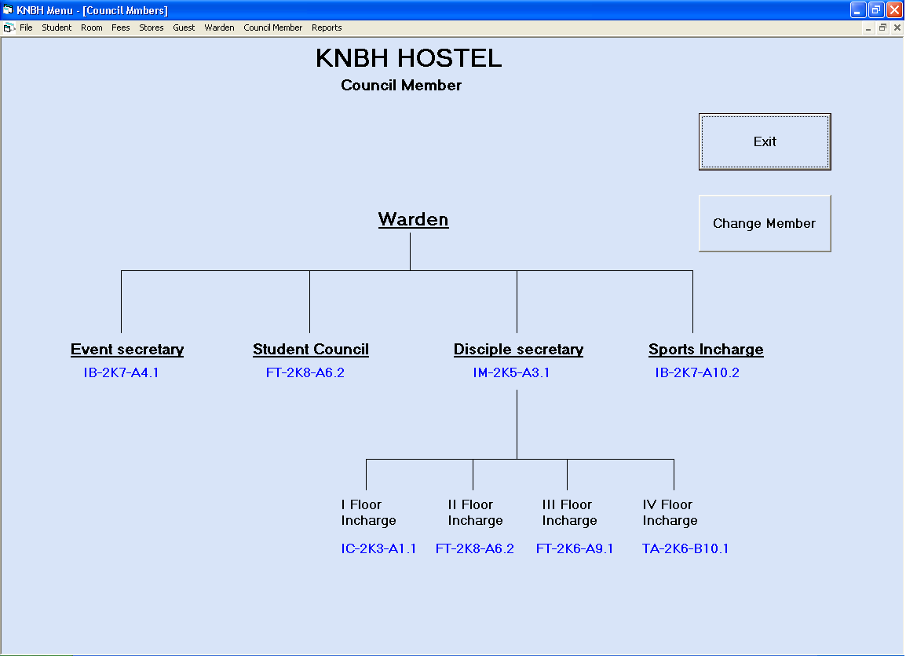

Council Member Part 2

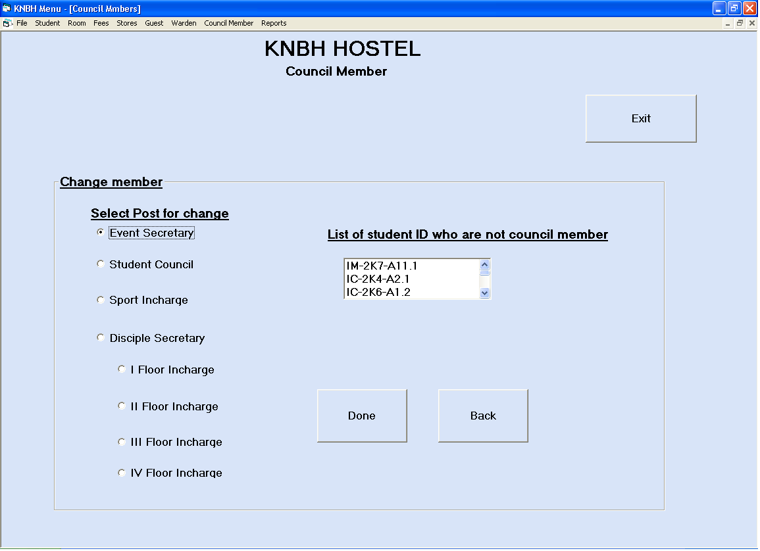

Leaving Hostel Part 1

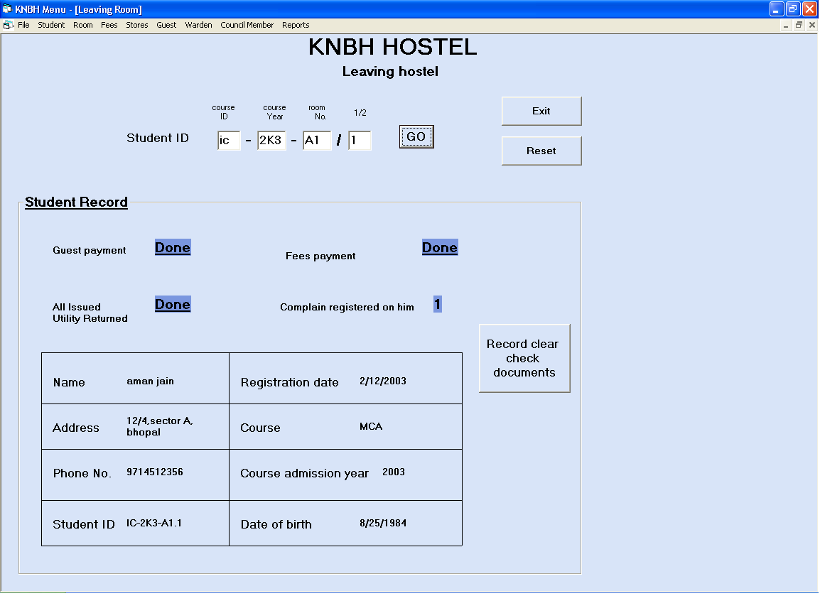

Leaving Hostel Part 2

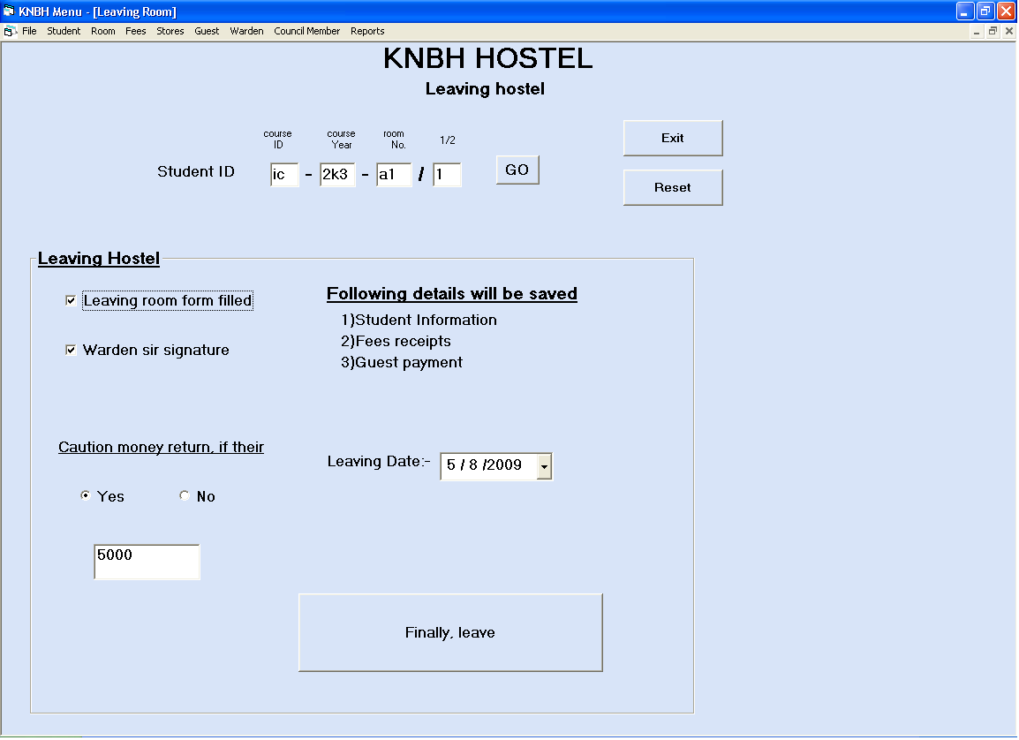

Report

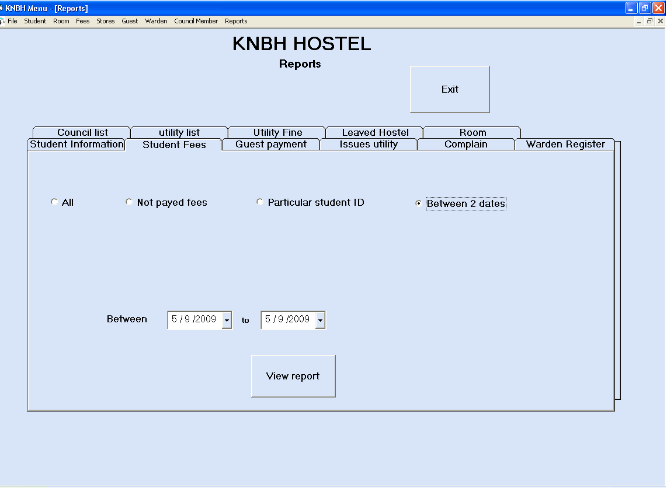

7. IMPLEMENTATION

7

IMPLEMENTATION

IMPLEMENTATION

Implementation is the process of converting the new designed system into the operational one. There are various types of implementation. Some of these are as follows:

- Implementation of a computer system to replace a manual system.
- Implementation of a new computer system to replace an existing system.
- Implementation of a modified application to replace an existing one.

We are following the first implementation method to implement our system. In implementing our system, we do not need to give very hard user training.

For conversion, we will use the parallel system method. The old system and the new system will be in operation simultaneously. This will provide the greatest security.

The new system will be implemented fully after sometime on the basis of feedback given by the user.

8. CODE SNIPPET

Admission

Dim c As String
Dim Y As String
Dim sstr As String

Private Sub addnew_Click()
update.Visible = False
save.Visible = True
Option1.Visible = True
Option2.Visible = True
Option3.Visible = True
Option4.Visible = True
Option5.Visible = True
Option6.Visible = True
year_list.Visible = True
regdt.Visible = True
dobdt.Visible = True
course_label.Visible = False
year_label.Visible = False
rd_label.Visible = False
dob_label.Visible = False

first.Enabled = False
last.Enabled = False
previous.Enabled = False
next1.Enabled = False
search.Enabled = False
delete.Enabled = False
exit1.Enabled = False
refresh1.Enabled = False
addnew.Enabled = False
Adodc1.Recordset.addnew
End Sub

Private Sub Option1_Click()
c = "IC"
course_label.Caption = "MCA"
End Sub

Private Sub Option2_Click()
c = "IM"
course_label.Caption = "MMS"
End Sub

Private Sub Option3_Click()
c = "IT"
course_label.Caption = "M Tech"
year_list.SetFocus
End Sub

Private Sub Option4_Click()
c = "IB"
course_label.Caption = "BCom"
End Sub

Private Sub Option5_Click()
c = "TA"
course_label.Caption = "MBA(ta)"
End Sub

Private Sub Option6_Click()
c = "FT"
course_label.Caption = "MBA(ft)"
End Sub

Private Sub reset_Click()
Option1.Value = False
Option2.Value = False
Option3.Value = False
Option4.Value = False
Option5.Value = False
Option6.Value = False
End Sub

Private Sub search_Click()
search_name.Enabled = True
search_id.Enabled = True
End Sub

Private Sub search_dob_Click()
sstr = InputBox("Please enter the Date of birth for search" + Chr(13) + "Format mm/dd/yyyy", "Date of Birth Search", "mm/dd/yyyy")
If Not sstr = "" Then
Adodc1.CommandType = adCmdText
Adodc1.RecordSource = "select * from student_info where date_of_birth like TO_DATE(''" & sstr & "'',''MM-DD-YYYY'')"
Adodc1.Refresh
If Adodc1.Recordset.EOF = True Then
MsgBox ("Their is no student with such Date of Birth")
Adodc1.CommandType = adCmdText
Adodc1.RecordSource = "select * from student_info "
Adodc1.Refresh
End If
End If
search_name.Enabled = False
search_id.Enabled = False
search_dob.Enabled = False
search_name.Value = False
search_id.Value = False
search_dob.Value = False
End Sub

Private Sub search_id_Click()
sstr = InputBox("Please enter the Student ID for search", "Student ID Search", "ID")
If Not sstr = "" Then
Adodc1.CommandType = adCmdText
Adodc1.RecordSource = "select * from student_info where student_id ='" & sstr & "'"
Adodc1.Refresh
If Adodc1.Recordset.EOF = True Then
MsgBox ("Their is no student with such Student ID")
Adodc1.CommandType = adCmdText
Adodc1.RecordSource = "select * from student_info "
Adodc1.Refresh
End If
End If
search_name.Enabled = False
search_id.Value = False
End Sub

Private Sub search_name_Click()
sstr = InputBox("Please enter the name for search", "Name Search", "NAME")
If Not sstr = "" Then
Adodc1.CommandType = adCmdText
Adodc1.RecordSource = "select * from student_info where name ='" & sstr & "'"
Adodc1.Refresh
If Adodc1.Recordset.EOF = True Then
MsgBox ("Their is no student with such Name")
Adodc1.CommandType = adCmdText
Adodc1.RecordSource = "select * from student_info "
Adodc1.Refresh
End If
End If
search_name.Enabled = False
search_id.Enabled = False
End Sub

Private Sub delete_Click()
returnvalue = MsgBox("Sure u want to delete", vbYesNo)
If returnvalue = 6 Then
Adodc1.Recordset.delete
Adodc1.Recordset.MoveNext
End If
End Sub

Private Sub exit1_Click()
Unload Me
End Sub

Private Sub first_Click()
Adodc1.Recordset.MoveFirst
End Sub

Private Sub Form_Load()
save.Visible = False
regdt.Visible = False
dobdt.Visible = False
Option1.Visible = False
regdt.Value = Date
regdt.MaxDate = Date
End Sub

Private Sub last_Click()
Adodc1.Recordset.MoveLast
End Sub

Private Sub name1_KeyPress(KeyAscii As Integer)
If (KeyAscii < 65 Or KeyAscii > 122) And KeyAscii <> vbKeyBack And KeyAscii <> vbKeySpace Then
If MsgBox("Enter valid name", vbOKOnly, "errors") = vbOK Then
KeyAscii = 0
End If
End If
End Sub

Private Sub next1_Click()
If Not Adodc1.Recordset.EOF Then
Adodc1.Recordset.MoveNext
Else
Adodc1.Recordset.MoveFirst
MsgBox ("Moved to first record as EOF")
End If
End Sub

Private Sub phone_KeyPress(KeyAscii As Integer)
If Not (IsNumeric(phone.Text & Chr(KeyAscii))) And KeyAscii <> vbKeyBack Then KeyAscii = 0
End Sub

Private Sub previous_Click()
If Not Adodc1.Recordset.BOF Then
Adodc1.Recordset.MovePrevious
Else
Adodc1.Recordset.MoveLast
MsgBox ("Moved to last record as BOF")
End If
End Sub

Private Sub refresh1_Click()
Adodc1.Refresh
End Sub

Private Sub save_Click()
If name1.Text = "" Then
MsgBox ("Enter the name")
name1.SetFocus
ElseIf address.Text = "" Then
MsgBox ("Enter the address")
address.SetFocus
ElseIf phone.Text = "" Then
MsgBox ("Enter the phone number")
phone.SetFocus
ElseIf Option1.Value = False And Option2.Value = False And Option3.Value = False And Option4.Value = False And Option5.Value = False And Option6.Value = False Then
MsgBox ("Please select a course first")
ElseIf year_list.SelCount = 0 Then
MsgBox ("Please select admission year of course")
year_list.SetFocus
Else
rd_label.Caption = regdt.Value
dob_label.Caption = dobdt.Value
regdt.Visible = False
dobdt.Visible = False
rd_label.Visible = True
dob_label.Visible = True
course_label.Visible = True
id_label.Caption = c

Option1.Visible = False
Option4.Visible = False
Option5.Visible = False
Option6.Visible = False

year_list.Visible = False
year_label.Caption = year_list.Text
If year_label.Caption = "2000" Then
Y = "2K0"
ElseIf year_label.Caption = "2001" Then
Y = "2K1"
ElseIf year_label.Caption = "2002" Then
Y = "2K2"
ElseIf year_label.Caption = "2003" Then
Y = "2K3"
ElseIf year_label.Caption = "2004" Then
Y = "2K4"
ElseIf year_label.Caption = "2005" Then
Y = "2K5"
ElseIf year_label.Caption = "2006" Then
Y = "2K6"
ElseIf year_label.Caption = "2007" Then
Y = "2K7"
ElseIf year_label.Caption = "2008" Then
Y = "2K8"
End If
year_label.Visible = True
id_label.Caption = id_label.Caption + "-" + Y + "-"

first.Enabled = True
last.Enabled = True
previous.Enabled = True
save.Visible = False
Adodc1.Recordset.update
reset_Click

End If
End Sub

Private Sub update_Click()
Adodc1.Recordset.update
End Sub

Room

Dim c As String
Dim v As String
Dim id As String
Dim n As String
Dim old As String
Dim session As String
Dim sem1 As String
Dim sem2 As String
Dim cyr As String
Dim excpt As Integer

Private Sub allot_Click()
If List4.SelCount = 0 Then
MsgBox ("Please select a student")
Else
excpt = 0
allot.Enabled = False
update.Enabled = True
c = List4.Text
Adodc2.CommandType = adCmdText
Adodc2.RecordSource = "select student_id from student_info where name ='" & c & "'"
Adodc2.Refresh
old = Adodc2.Recordset("student_id")
old_id_label.Caption = old
If vacancy_label.Caption = 1 Then
Adodc1.CommandType = adCmdText
Adodc1.RecordSource = " select * from room where ( room_no ='" & room_label.Caption & "' and vacancy = 1 )"
Adodc1.Refresh
If Adodc1.Recordset("first_id") = "NA" Then
v = "1"
excpt = 1
Else
v = "2"
End If
Else
v = "1"
End If
old = old + room_label + "." + v
new_id_label.Caption = old
End If
End Sub

Private Sub assign_course_Click()
If List1.SelCount = 0 Then
MsgBox ("PLease select a room")
Else
pass = InputBox("Please enter the PASSWORD", "Password", "Password")
If pass = "tiger" Then
room_label.Caption = List1.Text
Frame3.Visible = True
Adodc2.RecordSource = "select name from student_info where student_id like '__-___-'"
Adodc2.Refresh
Do While Adodc2.Recordset.EOF = False
List4.AddItem Adodc2.Recordset("name")
Adodc2.Recordset.MoveNext
Loop
End If
End If
End Sub

Private Sub assign_empty_Click()
If List2.SelCount = 0 And List3.SelCount = 0 Then
MsgBox ("Please select a room")
Else
pass = InputBox("Please enter the PASSWORD", "Password", "Password")
If pass = "tiger" Then
Frame3.Visible = True
update.Enabled = False
select_room.Visible = False
If one.Value = True Then
room_label.Caption = List2.Text
vacancy_label.Caption = 1
Else
room_label.Caption = List3.Text
vacancy_label.Caption = 2
End If

Adodc2.CommandType = adCmdText
Adodc2.RecordSource = "select name from student_info where student_id like '__-___-'"
Adodc2.Refresh
Do While Adodc2.Recordset.EOF = False
List4.AddItem Adodc2.Recordset("name")
Adodc2.Recordset.MoveNext
Loop
End If
End If
End Sub

Private Sub exit1_Click()
Unload Me
End Sub

Private Sub Form_Load()
select_room.Visible = False
Frame3.Visible = False
today_date.Value = Date
End Sub

Private Sub go_Click()
If Option1.Value = False And Option2.Value = False And Option3.Value = False And Option4.Value = False And Option5.Value = False And Option6.Value = False Then
MsgBox ("Please select a course else go for Empty room")
Else
k = List1.ListCount - 1
Do While k >= 0
List1.RemoveItem k
k = k - 1
Loop
If Option1.Value = True Then
c = "IC"
ElseIf Option2.Value = True Then
c = "IM"
ElseIf Option3.Value = True Then
c = "IT"
ElseIf Option4.Value = True Then
c = "IB"
ElseIf Option5.Value = True Then
c = "TA"
ElseIf Option6.Value = True Then
c = "FT"
End If
Adodc1.CommandType = adCmdText
Adodc1.RecordSource = "select room_no from room where (vacancy=1 and ( first_id like '" & c & "%' or second_id like '" & c & "%'))"
Adodc1.Refresh
If Adodc1.Recordset.EOF = True Then
MsgBox ("No room having vacancy for this course")
Else
List1.AddItem Adodc1.Recordset("room_no")
assign_course.Enabled = True
End If
End If
End Sub

Private Sub one_Click()
List2.Visible = True
Label7.Visible = False
assign_empty.Enabled = True
End Sub

Private Sub reset_Click()
k = List1.ListCount - 1
Do While k >= 0
List1.RemoveItem k
k = k - 1
Loop
k = List2.ListCount - 1
Do While k >= 0
List2.RemoveItem k
k = k - 1
Loop
k = List3.ListCount - 1
Do While k >= 0
List3.RemoveItem k
k = k - 1
Loop
k = List4.ListCount - 1
Do While k >= 0
List4.RemoveItem k
k = k - 1
Loop
start_allot.Visible = True
Check1.Value = Unchecked
Check2.Value = Unchecked
Check3.Value = Unchecked
Option3.Value = False
Option4.Value = False
Option5.Value = False
Option6.Value = False
one.Value = False
two.Value = False
End Sub

Private Sub start_allot_Click()
If Check1.Value And Check2.Value And Check3.Value Then
select_room.Visible = True
assign_course.Enabled = False
assign_empty.Enabled = False
start_allot.Visible = False

Adodc1.CommandType = adCmdText
Adodc1.RecordSource = "select room_no from room where vacancy=1"
Adodc1.Refresh
If Adodc1.Recordset.EOF = True Then
MsgBox ("No room having vacancy ONE")
Else
Do While Adodc1.Recordset.EOF = False
List2.AddItem Adodc1.Recordset("room_no")
Adodc1.Recordset.MoveNext
Loop
End If

Adodc1.CommandType = adCmdText
Adodc1.RecordSource = "select room_no from room where vacancy=2"
Adodc1.Refresh
If Adodc1.Recordset.EOF = True Then
MsgBox ("No room having vacancy TWO")
Else
Do While Adodc1.Recordset.EOF = False
List3.AddItem Adodc1.Recordset("room_no")
Adodc1.Recordset.MoveNext
Loop

End If
List2.Visible = False
Label7.Visible = False
Else
MsgBox ("Complete all three details first")
End If
End Sub

Private Sub two_Click()
List2.Visible = False
List3.Visible = True
Label6.Visible = False
Label7.Visible = True
assign_empty.Enabled = True
End Sub

Private Sub update_Click()
c = room_label.Caption
id = new_id_label.Caption
If vacancy_label.Caption = 1 Then
Adodc1.CommandType = adCmdText
Adodc1.RecordSource = "select * from room where room_no='" & c & "'"
Adodc1.Refresh
If excpt = 1 Then
Adodc1.Recordset("first_id") = id
Else
Adodc1.Recordset("second_id") = id
End If
Adodc1.Recordset("vacancy") = 0
Adodc1.Recordset.update
Adodc1.Refresh
Else
Adodc1.CommandType = adCmdText
Adodc1.RecordSource = "select * from room where room_no='" & c & "'"
Adodc1.Refresh
Adodc1.Recordset("first_id") = id
Adodc1.Recordset("vacancy") = 1
Adodc1.Recordset.update
Adodc1.Refresh
End If
n = List4.Text
Adodc2.CommandType = adCmdText
Adodc2.RecordSource = "select * from student_info where name ='" & n & "'"
Adodc2.Recordset.update
Adodc2.Refresh
MsgBox ("Room alloted successfully. THANK YOU!!!")
reset_Click
sem1 = "Jan-June"
sem2 = "July-Dec"
m = 0
j = today_date.Year - regdt.Year
yr = regdt.Year
If regdt.Month < 6 Then
m = (j * 2) + 1
i = 1
session = sem1 + Str(yr)

Else
m = (j * 2)
i = 0
session = sem2 + Str(yr)

End If

Do While m > 0
Adodc3.CommandType = adCmdText
Adodc3.Recordset.addnew
Adodc3.Recordset("student_id") = new_id_label.Caption
Adodc3.Recordset("semester") = session
Adodc3.Recordset.update
Adodc3.Refresh
m = m - 1
If (i = 0) Then
yr = yr + 1
session = sem1 + Str(yr)
i = 1
Else
session = sem2 + Str(yr)
i = 0

End If
Loop
End Sub

Fees Payment

Dim i As Integer
Dim a As Integer
Dim c As String
Dim j As Integer
Dim s As String

Private Sub cash_memo_GotFocus()
gdate.Caption = Date
gamount.Caption = Str(a)
End Sub

Private Sub cash_memo_KeyPress(KeyAscii As Integer)
If Not (IsNumeric(cash_memo.Text & Chr(KeyAscii))) And KeyAscii <> vbKeyBack Then KeyAscii = 0
End Sub

Private Sub payment_Click()
If sem_list.SelCount = 0 Then
MsgBox ("Please select a semester")
Else
fees_payment.Visible = True
Frame1.Visible = False
session.Caption = sem_list.Text
End If
End Sub

Private Sub reset_Click()
id.Text = ""
yr.Text = ""
room_no.Text = ""
num.Text = ""
k = sem_list.ListCount - 1
Do While k >= 0
sem_list.RemoveItem k
k = k - 1
Loop
fees_frame.Visible = False
Frame2.Visible = False
Option1.Value = False
Option2.Value = False
info.Caption = ""
Frame1.Visible = False
fees_payment.Visible = False
receipt_no.Text = ""
samount.Text = ""
session.Caption = ""
End Sub

Private Sub gupdate_Click()
If cash_memo.Text = "" Then
MsgBox ("Please enter cash memo number")
Else
Do While i > 0
Adodc4.CommandType = adCmdText
Adodc4.RecordSource = "select * from guest_payment where ( student_id ='" & c & "' and cash_memo = 0 )"
Adodc4.Refresh
Adodc4.Recordset("cash_memo") = cash_memo.Text
Adodc4.Recordset("date_of_payment") = gdate.Caption
Adodc4.Recordset.update
i = i - 1
Loop
MsgBox ("Guest fees paid successfully")
reset_Click
End If
End Sub

Private Sub supdate_Click()
If receipt_no.Text = "" Then
MsgBox ("Please enter the receipt number")
receipt_no.SetFocus
ElseIf samount.Text = "" Then

j = j - 1
s = sem_list.Text
Adodc1.CommandType = adCmdText
Adodc1.RecordSource = "select * from student_fees where ( student_id ='" & c & "' and semester ='" & s & "')"
Adodc1.Refresh
Adodc1.Recordset("receipt_no") = receipt_no.Text
Adodc1.Recordset("amount") = samount.Text
Adodc1.Recordset("date") = date_receipt.Value
Adodc1.Recordset.update
Adodc1.Refresh
MsgBox ("Fees paid successfully")
If j = 0 Then
reset_Click
Else
fees_payment.Visible = False
receipt_no.Text = ""
samount.Text = ""
go_Click
End If
End If
End Sub

Private Sub exit1_Click()
Unload Me
End Sub

Private Sub Form_Load()
fees_frame.Visible = False
fees_payment.Visible = False
Frame1.Visible = False
Frame2.Visible = False
Option1.Visible = False
Option2.Visible = False
date_receipt.Value = Date
date_receipt.MaxDate = Date
End Sub

Private Sub go_Click()
c = id.Text + "-" + yr.Text + "-" + room_no.Text + "." + num.Text
Adodc2.CommandType = adCmdText
Adodc2.RecordSource = "select name from student_info where student_id ='" & c & "'"
Adodc2.Refresh

If Adodc2.Recordset.EOF = True Then
MsgBox ("Their is no student with such Student ID")

Else
stu_name.Caption = Adodc2.Recordset("name")
r_no.Caption = room_no.Text
fees_frame.Visible = True

Adodc3.CommandType = adCmdText
Adodc3.RecordSource = "select * from guest_payment where student_id ='" & c & "'"
Adodc3.Refresh

Adodc1.CommandType = adCmdText
Adodc1.RecordSource = "select * from student_fees where ( student_id ='" & c & "' and receipt_no = 0 )"
Adodc1.Refresh
j = 0
If Adodc1.Recordset.EOF = True Then
info1.Caption = "Payment of semester done"
Else
Do While Adodc1.Recordset.EOF = False
j = j + 1
sem_list.AddItem Adodc1.Recordset("semester")
Adodc1.Recordset.MoveNext
Loop
info1.Caption = "Payment of " + Str(j) + " semester not done "
fee_info.Caption = "Select Semester for payment "
End If

Adodc1.CommandType = adCmdText
Adodc1.RecordSource = "select * from student_fees "
Adodc1.Refresh

Adodc4.CommandType = adCmdText
Adodc4.RecordSource = "select * from guest_payment where ( student_id ='" & c & "' and cash_memo = 0 )"
Adodc4.Refresh
i = 0
a = 0
If Adodc4.Recordset.EOF = True Then
info.Caption = "Payment of all guests done"
Else
Do While Adodc4.Recordset.EOF = False
i = i + 1
a = a + Adodc4.Recordset("amount")
Adodc4.Recordset.MoveNext
Loop
info.Caption = "Payment of guests not done please select the payment feild"
End If
If i > 0 And j > 0 Then
Option1.Visible = True
Option2.Visible = True
Else
If j > 0 Then
Frame1.Visible = True
End If
If i > 0 Then
Frame2.Visible = True
End If
End If
End If
End Sub

Private Sub Option1_Click()
gamount.Caption = ""
End Sub

Private Sub Option2_Click()
Frame2.Visible = True
Frame1.Visible = False
End Sub

Private Sub receipt_no_KeyPress(KeyAscii As Integer)
If Not (IsNumeric(receipt_no.Text & Chr(KeyAscii))) And KeyAscii <> vbKeyBack Then KeyAscii = 0
If Len(receipt_no.Text) > 4 Then KeyAscii = 0
End Sub

Private Sub samount_KeyPress(KeyAscii As Integer)
If Not (IsNumeric(samount.Text & Chr(KeyAscii))) And KeyAscii <> vbKeyBack Then KeyAscii = 0
If Len(samount.Text) > 3 Then KeyAscii = 0
End Sub

Guest

Dim c As String
Dim d As String
Dim n As Integer

Private Sub reset_Click()
id.Text = ""
yr.Text = ""
room_no.Text = ""
num.Text = ""
address.Text = ""
phone.Text = ""
Option1.Value = False
Option2.Value = False
Option3.Value = False
End Sub

Private Sub days_KeyPress(KeyAscii As Integer)
If Not (IsNumeric(days.Text & Chr(KeyAscii))) And KeyAscii <> vbKeyBack Then KeyAscii = 0
End Sub

Private Sub exit1_Click()
Unload Me
End Sub

Private Sub Form_Load()
guest_frame.Visible = False
End Sub

Private Sub go_Click()
c = id.Text + "-" + yr.Text + "-" + room_no.Text + "." + num.Text
Adodc2.CommandType = adCmdText
Adodc2.RecordSource = "select name from student_info where student_id ='" & c & "'"
Adodc2.Refresh

If Adodc2.Recordset.EOF = True Then
MsgBox ("Their is no student with such Student ID")

Else
stu_name.Caption = Adodc2.Recordset("name")
r_no.Caption = room_no.Text

Adodc1.CommandType = adCmdText
Adodc1.RecordSource = "select * from guest_payment where student_id ='" & c & "'"
Adodc1.Refresh
guest_frame.Visible = True
guest_date.Caption = Date
End If
End Sub

Private Sub name_KeyPress(KeyAscii As Integer)
If (KeyAscii < 65 Or KeyAscii > 122) And KeyAscii <> vbKeyBack And KeyAscii <> vbKeySpace Then
If MsgBox("Enter valid name", vbOKOnly, "errors") = vbOK Then
KeyAscii = 0
End If
End If
End Sub

Private Sub phone_KeyPress(KeyAscii As Integer)
If Not (IsNumeric(phone.Text & Chr(KeyAscii))) And KeyAscii <> vbKeyBack Then KeyAscii = 0
End Sub

Private Sub update_Click()
If g_name.Text = "" Then
MsgBox ("Please enter name")
g_name.SetFocus
ElseIf address.Text = "" Then
MsgBox ("Please enter address")
address.SetFocus
ElseIf phone.Text = "" Then
MsgBox ("Please enter Phone number")
phone.SetFocus
ElseIf days.Text = "" Then
MsgBox ("Please enter number of days")
days.SetFocus
ElseIf Option1.Value = False And Option2.Value = False And Option3.Value = False Then
MsgBox ("Please take a Identity first")
Else
c = id.Text + "-" + yr.Text + "-" + room_no.Text + "." + num.Text
If Option1.Value = True Then
d = "Institute ID"
ElseIf Option2.Value = True Then
d = "Dreiving licence"
ElseIf Option3.Value = True Then
d = "Voter ID card"
End If
a = days.Text
Adodc1.CommandType = adCmdText
Adodc1.RecordSource = "select * from guest_payment"
Adodc1.Refresh
Adodc1.Recordset.addnew
Adodc1.Recordset("student_id") = UCase(c)
Adodc1.Recordset("guest_name") = g_name.Text
Adodc1.Recordset("address") = address.Text
Adodc1.Recordset("phone") = phone.Text
Adodc1.Recordset("identity") = d
Adodc1.Recordset.update
Adodc1.Refresh
MsgBox ("Done successfully, student should pay the cooresponding amount ")
reset_Click
End If
End Sub

Issue Utility

Dim c As String
Dim u As String
Dim n As Integer

Private Sub check_Click()
If spt1.Value = False And spt2.Value = False And spt3.Value = False And spt4.Value = False And spt5.Value = False And tolt3.Value = False And tolt4.Value = False And tolt5.Value = False Then
MsgBox ("Please select a utility")
Else
Adodc2.CommandType = adCmdText
Adodc2.RecordSource = "select quantity from utility_list where utility_name ='" & u & "'"
Adodc2.Refresh
n = Adodc2.Recordset("quantity")
If n > 0 Then
returnvalue = MsgBox("Utility available. Want to Issue?", vbYesNo, "Issue")
If returnvalue = 6 Then
Label17.Visible = False
issue_frame.Visible = True
utility.Caption = u
student_id.Caption = id.Text + "-" + yr.Text + "-" + room_no.Text + "." + num.Text
issue_date.Caption = Date
End If
Else
MsgBox ("Utility not available")
End If
End If
End Sub

Private Sub reset_Click()
id.Text = ""
yr.Text = ""
room_no.Text = ""
num.Text = ""
student_id = ""
Label17.Visible = True
spt1.Value = False
spt2.Value = False
spt3.Value = False
spt4.Value = False
spt5.Value = False
rm1.Value = False
rm2.Value = False
rm3.Value = False
rm3.Value = False
rm4.Value = False
rm5.Value = False
tolt4.Value = False
tolt5.Value = False

End Sub

Private Sub days_KeyPress(KeyAscii As Integer)
If Not (IsNumeric(days.Text & Chr(KeyAscii))) And KeyAscii <> vbKeyBack Then KeyAscii = 0
End Sub

Private Sub exit1_Click()
Unload Me
End Sub

Private Sub Form_Load()
stores_frame.Visible = False
check.Enabled = False
issue_frame.Visible = False
End Sub

Private Sub go_Click()
c = id.Text + "-" + yr.Text + "-" + room_no.Text + "." + num.Text
Adodc1.CommandType = adCmdText
Adodc1.RecordSource = "select name from student_info where student_id ='" & c & "'"
Adodc1.Refresh

If Adodc1.Recordset.EOF = True Then
MsgBox ("Their is no student with such Student ID")
Else
stores_frame.Visible = True
stu_name.Caption = Adodc1.Recordset("name")
r_no.Caption = room_no.Text

Adodc3.CommandType = adCmdText
Adodc3.RecordSource = "select * from issue_utility where student_id ='" & c & "'"
Adodc3.Refresh
End If
End Sub
Private Sub rm1_Click()
u = rm1.Caption
check.Enabled = True
End Sub

Private Sub rm2_Click()
u = rm2.Caption
check.Enabled = True
End Sub

Private Sub rm3_Click()
u = rm3.Caption
check.Enabled = True
End Sub

End Sub

Private Sub rm5_Click()
u = rm5.Caption
check.Enabled = True
End Sub

Private Sub rm6_Click()
u = rm6.Caption
check.Enabled = True
End Sub

Private Sub spt1_Click()
u = spt1.Caption
check.Enabled = True
End Sub

Private Sub spt4_Click()
u = spt4.Caption
check.Enabled = True
End Sub

Private Sub spt5_Click()
u = spt5.Caption
check.Enabled = True
End Sub

Private Sub tolt1_Click()
u = tolt1.Caption
check.Enabled = True
End Sub

Private Sub tolt2_Click()
u = tolt2.Caption
check.Enabled = True
End Sub

Private Sub tolt5_Click()
u = tolt5.Caption
check.Enabled = True
End Sub

Private Sub update_Click()
If days.Text = "" Then
MsgBox ("Please select number of days")
days.SetFocus
Else
Adodc3.CommandType = adCmdText
Adodc3.RecordSource = "select * from issue_utility"
Adodc3.Refresh
Adodc3.Recordset.addnew
Adodc3.Recordset("student_id") = UCase(student_id.Caption)
Adodc3.Recordset("utility_name") = utility.Caption
Adodc3.Recordset("date_of_issue") = issue_date.Caption
Adodc3.Recordset("date_of_return") = Date + Val(days.Text)
Adodc3.Recordset("days") = days.Text
Adodc3.Recordset.update
Adodc3.Refresh
u = utility.Caption
Adodc2.CommandType = adCmdText
Adodc2.RecordSource = "select * from utility_list where utility_name ='" & u & "'"
Adodc2.Refresh
Adodc2.Recordset("quantity") = Adodc2.Recordset("quantity") - 1
Adodc2.Recordset.update
Adodc2.Refresh
MsgBox ("Issued utility successfully")
reset_Click
End If
End Sub

Return Utility

Dim i As Integer
Dim c As String

Private Sub exit1_Click()
Unload Me
End Sub

Private Sub Form_Load()
stores_frame.Visible = False
dt_fine.Value = Date
End Sub

Private Sub go_Click()
c = id.Text + "-" + yr.Text + "-" + room_no.Text + "." + num.Text
Adodc1.CommandType = adCmdText
Adodc1.RecordSource = "select * from student_info where student_id ='" & c & "'"
Adodc1.Refresh

If Adodc1.Recordset.EOF = True Then
MsgBox ("Their is no student with such Student ID")
Else
Adodc3.CommandType = adCmdText
Adodc3.RecordSource = "select * from issue_utility where student_id ='" & c & "'"
Adodc3.Refresh
i = 0
If Adodc3.Recordset.EOF = True Then
returnvalue = MsgBox("This student has no utility issued. Want to search more or exit", vbYesNo + vbExclamation)
If returnvalue = 6 Then
reset_Click
Else
Unload Me
End If
Else
stores_frame.Visible = True
Do While Adodc3.Recordset.EOF = False
i = i + 1
Adodc3.Recordset.MoveNext
Loop
Adodc3.CommandType = adCmdText
Adodc3.RecordSource = "select * from issue_utility where student_id ='" & c & "'"
Adodc3.Refresh
number.Caption = i
If i = 1 Then
next1.Visible = False
previous.Visible = False
End If
date_issue.Caption = dt.Value
date_return.Caption = dt.Value + Val(days.Caption)

If (dt_fine.Value - (dt.Value + Val(days.Caption))) > 0 Then
amount.Caption = 5 * (dt_fine.Value - (dt.Value + Val(days.Caption)))
late.Caption = dt_fine.Value - (dt.Value + Val(days.Caption))
Else
amount.Caption = "0"
late.Caption = "0"
End If
End If
End If
End Sub

Private Sub next1_Click()
If Not Adodc3.Recordset.EOF Then
Adodc3.Recordset.MoveNext
Else
Adodc3.Recordset.MoveFirst
End If
date_issue.Caption = dt.Value
date_return.Caption = dt.Value + Val(days.Caption)

If (dt_fine.Value - (dt.Value + Val(days.Caption))) > 0 Then
amount.Caption = 5 * (dt_fine.Value - (dt.Value + Val(days.Caption)))
late.Caption = dt_fine.Value - (dt.Value + Val(days.Caption))
Else
amount.Caption = "0"
late.Caption = "0"
End If
If u_name.Caption = "" Then
return_utility.Enabled = False
Else
return_utility.Enabled = True
End If
End Sub

Private Sub previous_Click()
If Not Adodc3.Recordset.BOF Then
Adodc3.Recordset.MovePrevious
Else
Adodc3.Recordset.MoveLast
End If
date_issue.Caption = dt.Value
date_return.Caption = dt.Value + Val(days.Caption)

If (dt_fine.Value - (dt.Value + Val(days.Caption))) > 0 Then
amount.Caption = 5 * (dt_fine.Value - (dt.Value + Val(days.Caption)))
late.Caption = dt_fine.Value - (dt.Value + Val(days.Caption))
Else
amount.Caption = "0"
late.Caption = "0"
End If
If u_name.Caption = "" Then
return_utility.Enabled = False
Else
return_utility.Enabled = True
End If
End Sub

Private Sub reset_Click()
stores_frame.Visible = False
id.Text = ""
End Sub

Private Sub return_utility_Click()
If Val(amount.Caption) = 0 Then
same_Click
Else
Memo = InputBox("Take Rs" + amount.Caption + "/-" + Chr(13) + "enter the cash memo number", "Cash Memo", "Cash Memo")
If Not Memo = "" Then
Adodc4.CommandType = adCmdText
Adodc4.RecordSource = "select * from utility_fine"
Adodc4.Refresh
Adodc4.Recordset.addnew
Adodc4.Recordset("student_id") = id.Text + "-" + yr.Text + "-" + room_no.Text + "." + num.Text
Adodc4.Recordset("cash_memo") = Memo
Adodc4.Recordset("amount") = amount.Caption
Adodc4.Recordset("date") = dt_fine.Value
Adodc4.Recordset.update
Adodc4.Refresh
same_Click
End If
End If
End Sub

Private Sub same_Click()
i = i - 1
a = u_name.Caption
Adodc3.CommandType = adCmdText
Adodc3.RecordSource = "select * from issue_utility where student_id ='" & u_name.Caption & "'"
Adodc3.Recordset.delete
Adodc3.Refresh
Adodc3.CommandType = adCmdText
Adodc3.RecordSource = "select * from issue_utility where student_id ='" & u_name.Caption & "'"
Adodc3.Refresh

Adodc2.CommandType = adCmdText
Adodc2.RecordSource = "select * from utility_list where utility_name ='" & a & "'"
Adodc2.Refresh
Adodc2.Recordset("quantity") = Adodc2.Recordset("quantity") + 1
Adodc2.Recordset.update
Adodc2.Refresh
MsgBox ("Record updated successfully!!")
If i = 0 Then
reset_Click
Else
go_Click
End If
End Sub

Complain

Dim c As String
Dim d As String
Dim a As String
Dim u As String

Private Sub reset_Click()
id.Text = ""
yr.Text = ""
room_no.Text = ""
num.Text = ""
Frame1.Enabled = False
Option1.Value = False
Option2.Value = False
Option3.Value = False
complain_text.Text = ""
urgent.Value = Unchecked
End Sub

Private Sub complain_text_LostFocus()
If Option1.Value = True Then
authority.Caption = "Stores will handle"
ElseIf Option2.Value = True Then
authority.Caption = "Attendend will handle"
ElseIf Option3.Value = True Then
authority.Caption = "Wardon will handle"
End If
End Sub

Private Sub exit1_Click()
Unload Me
End Sub

Private Sub Form_Load()
complain_frame.Visible = False
Frame1.Enabled = False
End Sub

Private Sub go_Click()
c = id.Text + "-" + yr.Text + "-" + room_no.Text + "." + num.Text
Adodc2.CommandType = adCmdText
Adodc2.RecordSource = "select name from student_info where student_id ='" & c & "'"
Adodc2.Refresh

If Adodc2.Recordset.EOF = True Then
MsgBox ("Their is no student with such Student ID")

Else
complain_frame.Visible = True
stu_name.Caption = Adodc2.Recordset("name")
r_no.Caption = room_no.Text

Adodc1.CommandType = adCmdText
Adodc1.RecordSource = "select * from student_complain where student_id ='" & c & "'"
Adodc1.Refresh
End If
End Sub

Private Sub Option3_Click()
Frame1.Enabled = True
comp_date.Caption = Date
End Sub

Private Sub update_Click()
c = id.Text + "-" + yr.Text + "-" + room_no.Text + "." + num.Text
If Option1.Value = True Then
d = "Room"
a = "Stores"
ElseIf Option2.Value = True Then
d = "Mess"
a = "Attendent"
ElseIf Option3.Value = True Then
d = "Other"
a = "Warden"
End If

If urgent.Value = Checked Then
u = "Yes"
Else
u = "No"
End If

Adodc1.CommandType = adCmdText
Adodc1.RecordSource = "select * from student_complain"
Adodc1.Refresh
Adodc1.Recordset.addnew
Adodc1.Recordset("student_id") = UCase(c)
Adodc1.Recordset("complain_type") = d
Adodc1.Recordset("complain_text") = complain_text.Text
Adodc1.Recordset("date") = comp_date.Caption
Adodc1.Recordset("authority") = a
Adodc1.Recordset("urgency") = u
Adodc1.Recordset.update
Adodc1.Refresh
MsgBox ("Update done succesfully")
reset_Click
End Sub

Warden Register

Dim u As String
Dim c As String
Dim pass As String

Private Sub reg_comp_Click()
stab.Visible = False
complain_frame.Visible = True
End Sub

Private Sub reset_Click()
id.Text = ""
yr.Text = ""
room_no.Text = ""
num.Text = ""
stab.Visible = False
complain_frame.Visible = False
End Sub

Private Sub complain_text_GotFocus()
comp_date.Caption = Date
End Sub

Private Sub exit1_Click()
Unload Me
End Sub

Private Sub Form_Load()
stab.Visible = False
complain_frame.Visible = False
MSHFlexGrid1.Visible = False
Label13.Visible = False
pass = InputBox("Please enter the PASSWORD", "Password", "Password")
If Not pass = "" Then
If pass = "warden" Then
MsgBox ("Welcome sir!!!!")
Else
Unload Me
End If
Else
Unload Me
End If

End Sub

Private Sub go_Click()
c = id.Text + "-" + yr.Text + "-" + room_no.Text + "." + num.Text
Adodc2.CommandType = adCmdText
Adodc2.RecordSource = "select * from student_info where student_id ='" & c & "'"
Adodc2.Refresh

If Adodc2.Recordset.EOF = True Then
MsgBox ("Their is no student with such Student ID")

Else
stab.Visible = True
Adodc1.CommandType = adCmdText
Adodc1.RecordSource = "select * from wardon_register where student_id ='" & c & "'"
Adodc1.Refresh
i = 0
If Adodc1.Recordset.EOF = True Then
complain.Caption = "0"
Else
Do While Adodc1.Recordset.EOF = False
i = i + 1
Adodc1.Recordset.MoveNext
Loop
MSHFlexGrid1.Visible = True
Label13.Visible = True
complain.Caption = i
End If

Adodc4.CommandType = adCmdText
Adodc4.RecordSource = "select * from issue_utility where student_id ='" & c & "'"
Adodc4.Refresh
If Adodc4.Recordset.EOF = True Then
utility_returned.Caption = "Done"
Else
utility_returned.Caption = "Not"
End If

Adodc5.CommandType = adCmdText
Adodc5.RecordSource = "select * from student_fees where ( student_id ='" & c & "' and receipt_no = 0 )"
Adodc5.Refresh
If Adodc5.Recordset.EOF = True Then
fees_payment.Caption = "Done"
Else
fees_payment.Caption = "No"
End If

End If
End Sub

Private Sub update_Click()
If complain_text = "" Then
MsgBox ("Please fill the complain")
complain_text.SetFocus
Else
If police.Value = Checked Then
u = "Yes"
Else
u = "No"
End If

Adodc1.CommandType = adCmdText
Adodc1.RecordSource = "select * from wardon_register"
Adodc1.Refresh
Adodc1.Recordset.addnew
Adodc1.Recordset("student_id") = UCase(c)
Adodc1.Recordset("complain_text") = complain_text.Text
Adodc1.Recordset("date") = comp_date.Caption
Adodc1.Refresh
MsgBox ("Complain registered succesfully")
reset_Click
End If
End Sub

Council Member

Private Sub back_Click()
change_frame.Visible = False
change.Visible = True
Adodc1.CommandType = adCmdText
Adodc1.RecordSource = "select * from council_member"
Adodc1.Refresh
End Sub

Private Sub change_Click()
change.Visible = False
change_frame.Visible = True
done.Enabled = False
id_list.Enabled = False
i = 0
Adodc1.CommandType = adCmdText
Adodc1.RecordSource = "select * from council_member"
Adodc1.Refresh
Adodc2.CommandType = adCmdText
Adodc2.RecordSource = "select * from student_info where student_id NOT like '__-___-'"
Adodc2.Refresh
Do While Adodc2.Recordset.EOF = False
If Adodc2.Recordset("student_id") = Adodc1.Recordset("event") Then
Adodc2.Recordset.MoveNext
ElseIf Adodc2.Recordset("student_id") = Adodc1.Recordset("student_council") Then
Adodc2.Recordset.MoveNext
ElseIf Adodc2.Recordset("student_id") = Adodc1.Recordset("discipline_head") Then
Adodc2.Recordset.MoveNext
ElseIf Adodc2.Recordset("student_id") = Adodc1.Recordset("sport") Then
Adodc2.Recordset.MoveNext
ElseIf Adodc2.Recordset("student_id") = Adodc1.Recordset("floor1") Then
Adodc2.Recordset.MoveNext
ElseIf Adodc2.Recordset("student_id") = Adodc1.Recordset("floor4") Then
Adodc2.Recordset.MoveNext
Else
id_list.AddItem Adodc2.Recordset("student_id")
i = i + 1
Adodc2.Recordset.MoveNext
End If
Loop
End Sub

Private Sub done_Click()
If Option1.Value = False And Option2.Value = False And Option3.Value = False And Option4.Value = False And Option5.Value = False And Option6.Value = False And Option7.Value = False And Option8.Value = False Then
MsgBox ("Please select a Post for change")
ElseIf id_list.SelCount = 0 Then
MsgBox ("Please select a Student_id")
Else
new_id = id_list.Text
Adodc1.CommandType = adCmdText
Adodc1.RecordSource = "select * from council_member"
Adodc1.Refresh
If Option1.Value = True Then
Adodc1.Recordset("event") = new_id
ElseIf Option5.Value = True Then
Adodc1.Recordset("floor1") = new_id
ElseIf Option6.Value = True Then
Adodc1.Recordset("floor2") = new_id
ElseIf Option7.Value = True Then
Adodc1.Recordset("floor3") = new_id
ElseIf Option8.Value = True Then
Adodc1.Recordset("floor4") = new_id
End If
Adodc1.Recordset.update
Adodc1.Refresh
MsgBox ("Council member changed successfully!!!")
change_Click
End If
End Sub

Private Sub exit1_Click()
Unload Me
End Sub

Private Sub Form_Load()
change_frame.Visible = False
End Sub

Private Sub Option1_Click()
done.Enabled = True
id_list.Enabled = True
End Sub

Private Sub Option2_Click()
done.Enabled = True
id_list.Enabled = True
End Sub

Private Sub Option6_Click()
done.Enabled = True
id_list.Enabled = True
End Sub

Private Sub Option7_Click()
done.Enabled = True
id_list.Enabled = True
End Sub

Private Sub Option8_Click()
done.Enabled = True
id_list.Enabled = True
End Sub

Leaving Hostel

Dim i As Integer
Dim c As String

Private Sub reset_Click()
id.Text = ""
yr.Text = ""
room_no.Text = ""
num.Text = ""
Option2.Value = False
check1.Value = Unchecked
check2.Value = Unchecked
dd_no.Text = ""
dd_no.Visible = False

End Sub

Private Sub done_Click()
Adodc2.CommandType = adCmdText
Adodc2.RecordSource = "select * from student_info where student_id ='" & c & "'"
Adodc2.Refresh
f1 = Adodc2.Recordset("name")
f2 = Adodc2.Recordset("address")
f3 = Adodc2.Recordset("phone")
f4 = Adodc2.Recordset("course")
Adodc2.Refresh

Adodc7.CommandType = adCmdText
Adodc7.RecordSource = "select * from room where ( first_id ='" & c & "' or second_id = '" & c & "')"
Adodc7.Refresh
f10 = Adodc7.Recordset("room_no")
If Adodc7.Recordset("first_id") = UCase(c) Then
Adodc7.Recordset("first_id") = f1
Else
Adodc7.Recordset("second_id") = f1
End If
Adodc7.Recordset("vacancy") = Adodc7.Recordset("vacancy") + 1
Adodc7.Recordset.update
Adodc7.Refresh

j = 0
Adodc3.CommandType = adCmdText
Adodc3.RecordSource = "select * from guest_payment where student_id ='" & c & "'"
Adodc3.Refresh
If Adodc3.Recordset.EOF = False Then
Do While Adodc3.Recordset.EOF = False
f8 = f8 + Str(Adodc3.Recordset("cash_memo"))
f8 = f8 + " ,"
j = j + 1
Adodc3.Recordset.MoveNext
Loop
End If
Do While j > 0
Adodc3.CommandType = adCmdText
Adodc3.RecordSource = "select * from guest_payment where student_id ='" & c & "'"
Adodc3.Refresh
If Adodc3.Recordset.EOF = False Then
Adodc3.Recordset("student_id") = f1
Adodc3.Recordset.update
Adodc3.Refresh
End If
j = j - 1
Loop

j = 0
Adodc5.CommandType = adCmdText
Adodc5.RecordSource = "select * from student_fees where student_id ='" & c & "'"
Adodc5.Refresh
If Adodc5.Recordset.EOF = False Then
Do While Adodc5.Recordset.EOF = False
f9 = f9 + Str(Adodc5.Recordset("receipt_no"))
f9 = f9 + " ,"
j = j + 1
Adodc5.Recordset.MoveNext
Loop
End If

j = 0
Adodc6.CommandType = adCmdText
Adodc6.RecordSource = "select * from wardon_register where student_id ='" & c & "'"
End If
Do While j > 0
Adodc6.CommandType = adCmdText
Adodc6.RecordSource = "select * from wardon_register where student_id ='" & c & "'"
Adodc6.Refresh
If Adodc6.Recordset.EOF = False Then
Adodc6.Recordset("student_id") = f1
Adodc6.Recordset.update
Adodc6.Refresh
End If
j = j - 1
Loop

j = 0
Adodc8.CommandType = adCmdText
Adodc8.RecordSource = "select * from student_complain where student_id ='" & c & "'"
Adodc8.Refresh
If Adodc8.Recordset.EOF = False Then
Do While Adodc8.Recordset.EOF = False
j = j + 1
Adodc8.Recordset.MoveNext
Loop
End If
Do While j > 0
Adodc8.CommandType = adCmdText
Adodc8.RecordSource = "select * from student_complain where student_id ='" & c & "'"
Adodc8.Refresh
If Adodc8.Recordset.EOF = False Then
Adodc8.Recordset.delete
Adodc8.Refresh
End If
j = j - 1
Loop

j = 0
Adodc9.CommandType = adCmdText
Adodc9.RecordSource = "select * from utility_fine where student_id ='" & c & "'"
Adodc9.Refresh
If Adodc9.Recordset.EOF = False Then
Do While Adodc9.Recordset.EOF = False
j = j + 1
Adodc9.Recordset.MoveNext
Loop
End If
Do While j > 0
Adodc9.Refresh
End If
j = j - 1
Loop
If Option1.Value = True Then
f11 = dd_no.Text
Else
f11 = No
End If
Adodc1.CommandType = adCmdText
Adodc1.RecordSource = "select * from leave_hostel"
Adodc1.Refresh
Adodc1.Recordset.addnew
Adodc1.Recordset("name") = f1
Adodc1.Recordset("address") = f2
Adodc1.Recordset("phone") = f3
Adodc1.Recordset("course") = f4
Adodc1.Recordset("course_year") = f5
Adodc1.Recordset("registration_date") = f6
Adodc1.Recordset("date_of_birth") = f7
Adodc1.Recordset("guest_payment") = f8
Adodc1.Recordset("fee_receipt") = f9
Adodc1.Recordset("room_no") = f10
Adodc1.Recordset("leave_date") = leave_date.Value
Adodc1.Recordset("caution_money") = f11
Adodc1.Recordset.update
Adodc1.Refresh
MsgBox ("Student Updation done successfully!!! Room can be cleaned")
reset_Click
End Sub

Private Sub exit1_Click()
Unload Me
End Sub

Private Sub dd_no_KeyPress(KeyAscii As Integer)
If Not (IsNumeric(dd_no.Text & Chr(KeyAscii))) And KeyAscii <> vbKeyBack Then KeyAscii = 0
End Sub

Private Sub final_leave_Click()
If check1.Value And check2.Value Then
If Option1.Value = False And Option2.Value = False Then
MsgBox ("Please select the caution money payment YES/NO")
Else
If Option1.Value = True Then
If dd_no.Text = "" Then
MsgBox ("Please enter the DD number of caution money")
Else
done_Click
End If
Else
done_Click
End If
End If
Else
MsgBox ("Please fill the form and warden sir signature")
End If
End Sub

Private Sub Option1_Click()
dd_no.Visible = True
End Sub

Private Sub Form_Load()
record_clear.Enabled = False
student_frame.Visible = False
leave_frame.Visible = False
leave_date.Value = Date
End Sub

Private Sub go_Click()
c = id.Text + "-" + yr.Text + "-" + room_no.Text + "." + num.Text
Adodc2.CommandType = adCmdText
Adodc2.RecordSource = "select * from student_info where student_id ='" & c & "'"
Adodc2.Refresh

If Adodc2.Recordset.EOF = True Then
MsgBox ("Their is no student with such Student ID")

Else
student_frame.Visible = True
m = 0
Adodc3.CommandType = adCmdText
Adodc3.RecordSource = "select * from guest_payment where ( student_id ='" & c & "' and cash_memo = 0 )"
Adodc3.Refresh
If Adodc3.Recordset.EOF = True Then
guest_payment.Caption = "Done"
m = m + 1
Else
guest_payment.Caption = "No"
End If

Adodc4.CommandType = adCmdText
Adodc4.RecordSource = "select * from issue_utility where student_id ='" & c & "'"
Adodc4.Refresh
If Adodc4.Recordset.EOF = True Then
utility_returned.Caption = "Done"
m = m + 1
Else
utility_returned.Caption = "No"
End If

Adodc5.CommandType = adCmdText
Adodc5.RecordSource = "select * from student_fees where ( student_id ='" & c & "' and receipt_no = 0 )"
Adodc5.Refresh
If Adodc5.Recordset.EOF = True Then
fees_payment.Caption = "Done"
m = m + 1
Else
fees_payment.Caption = "No"
End If
i = 0
Adodc6.CommandType = adCmdText
Adodc6.RecordSource = "select * from wardon_register where student_id ='" & c & "'"
Adodc6.Refresh
If Adodc6.Recordset.EOF = True Then
complain.Caption = "0"
Else
Do While Adodc6.Recordset.EOF = False
i = i + 1
Adodc6.Recordset.MoveNext
Loop
complain.Caption = i
End If
If m = 3 Then
record_clear.Enabled = True
End If
End If
End Sub

Private Sub record_clear_Click()
student_frame.Visible = False
leave_frame.Visible = True
dd_no.Visible = False
End Sub

Report

Private Sub Command1_Click()
Data1.rsutility_list.Filter = adFilterNone
Set rpt_utility_list.DataSource = Data1
rpt_utility_list.Show
End Sub

Private Sub Command2_Click()
Data1.rsutility_fine.Filter = adFilterNone
Set rpt_utility_fine.DataSource = Data1
rpt_utility_fine.Show
End Sub

Private Sub Command3_Click()
Data1.rsleave_hostel.Filter = adFilterNone
Set rpt_leave_hostel.DataSource = Data1
rpt_leave_hostel.Show
End Sub

Private Sub Command4_Click()
Data1.rscouncil_member.Filter = adFilterNone
Set rpt_council_member.DataSource = Data1
rpt_council_member.Show
End Sub

Private Sub complain_report_Click()
If Option15.Value = False And Option12.Value = False And Option13.Value = False And Option14.Value = False Then
MsgBox ("Please select a option to generate report")
Else
If Option15.Value = True Then
Data1.rsstudent_complain.Filter = adFilterNone
End If
If Option12.Value = True Then
If Text4.Text = "" Then
MsgBox ("Please enter a Type of complain")
Else
Data1.rsstudent_complain.Filter = "complain_type='" & Text4.Text & "'"
End If
End If
If Option14.Value = True Then
If Text4.Text = "" Then
MsgBox ("Please enter a student id")
Else
Data1.rsstudent_complain.Filter = "student_id='" & Text4.Text & "'"
End If
End If
If Option13.Value = True Then
If dt5.Value < dt6.Value Then
Data1.rsstudent_complain.Filter = "date >=#" & dt5.Value & "# and date <=#" & dt6.Value & "#"
Else
Data1.rsstudent_complain.Filter = "date >=#" & dt6.Value & "# and date <=#" & dt5.Value & "#"
End If
End If
Set rpt_student_complain.DataSource = Data1
rpt_student_complain.Show
End If
End Sub

Private Sub fee_report_Click()
If Option1.Value = False And Option2.Value = False And Option3.Value = False And Option4.Value = False Then
MsgBox ("Please select a option to generate report")
Else
If Option1.Value = True Then
Data1.rsstudent_fees.Filter = adFilterNone
End If
If Option2.Value = True Then
If Text1.Text = "" Then
MsgBox ("Please enter a student id")
Else
Data1.rsstudent_fees.Filter = "student_id='" & Text1.Text & "'"
End If
End If
If Option3.Value = True Then
If dt1.Value < dt2.Value Then
Data1.rsstudent_fees.Filter = "date >=#" & dt1.Value & "# and date <=#" & dt2.Value & "#"
Else
Data1.rsstudent_fees.Filter = "date >=#" & dt2.Value & "# and date <=#" & dt1.Value & "#"
End If
End If
If Option4.Value = True Then
Data1.rsstudent_fees.Filter = "receipt_no=0"
End If
Set rpt_student_fees.DataSource = Data1
rpt_student_fees.Show
End If
End Sub

Private Sub exit1_Click()
Unload Me
End Sub

Private Sub Form_Load()
dt1.Value = Date
dt2.Value = Date
dt1.Visible = False
dt2.Visible = False
Text1.Visible = False
Label5.Visible = False
Label4.Visible = False
Label3.Visible = False

gdt1.Value = Date
gdt2.Value = Date
gdt1.Visible = False
gLabel4.Visible = False
gLabel3.Visible = False

Label6.Visible = False
Text2.Visible = False

Label7.Visible = False
Label8.Visible = False
Label9.Visible = False
Text3.Visible = False
dt3.Value = Date
dt4.Value = Date
dt3.Visible = False
dt4.Visible = False

Label10.Visible = False
Label13.Visible = False
dt5.Value = Date
dt6.Value = Date
dt5.Visible = False
dt6.Visible = False
End Sub

Private Sub issue_report_Click()
If Option10.Value = False And Option9.Value = False And Option8.Value = False And Option11.Value = False Then
MsgBox ("Please select a option to generate report")
Else
If Option10.Value = True Then
Data1.rsissue_utility.Filter = adFilterNone
End If
If Option9.Value = True Then
If Text3.Text = "" Then
MsgBox ("Please enter a student id")
Else
Data1.rsissue_utility.Filter = "student_id='" & Text3.Text & "'"
End If
End If
If Option8.Value = True Then
If dt3.Value < dt4.Value Then
Data1.rsissue_utility.Filter = "date_of_issue >=#" & dt3.Value & "# and date_of_issue <=#" & dt4.Value & "#"
Else
Data1.rsissue_utility.Filter = "date_of_issue >=#" & dt4.Value & "# and date_of_issue <=#" & dt3.Value & "#"
End If
End If
If Option11.Value = True Then
If dt3.Value < dt4.Value Then
Data1.rsissue_utility.Filter = "date_of_return >=#" & dt3.Value & "# and date_of_return <=#" & dt4.Value & "#"
Else
Data1.rsissue_utility.Filter = "date_of_return >=#" & dt4.Value & "# and date_of_return <=#" & dt3.Value & "#"
End If
End If
Set rpt_issue_utility.DataSource = Data1
rpt_issue_utility.Show
End If
End Sub

Private Sub Option1_Click()
dt1.Visible = False
dt2.Visible = False
Text1.Visible = False
Label5.Visible = False
Label4.Visible = False
Label3.Visible = False
End Sub

Private Sub Option11_Click()
Text3.Visible = False
Label7.Visible = False
dt3.Visible = True
dt4.Visible = True
Label9.Visible = True
Label8.Visible = True
End Sub

Private Sub Option12_Click()
Label10.Visible = False
Label13.Visible = True
Label11.Visible = False
Label12.Visible = False
Text4.Visible = True
dt5.Visible = False
dt6.Visible = False
End Sub

Private Sub Option13_Click()
Label10.Visible = False
Label13.Visible = False
Label11.Visible = True
Label12.Visible = True
Text4.Visible = False
dt5.Visible = True
dt6.Visible = True
End Sub

Private Sub Option14_Click()
Label10.Visible = True
Label13.Visible = False
Label11.Visible = False
Label12.Visible = False
Text4.Visible = True
dt5.Visible = False
dt6.Visible = False
End Sub

Private Sub Option2_Click()
Label4.Visible = False
Label3.Visible = False
dt1.Visible = False
dt2.Visible = False
Text1.Visible = True
Label5.Visible = True
End Sub

Private Sub Option3_Click()
Label4.Visible = True
Label3.Visible = True
dt1.Visible = True
dt2.Visible = True
Text1.Visible = False
Label5.Visible = False
End Sub

Private Sub gOption1_Click()
gdt1.Visible = False
gdt2.Visible = False
gText1.Visible = False
gLabel5.Visible = False
gLabel4.Visible = False
gLabel3.Visible = False
End Sub

Private Sub gOption2_Click()
gLabel4.Visible = False
gLabel3.Visible = False
gdt1.Visible = False
gdt2.Visible = False
gText1.Visible = True
gLabel5.Visible = True
End Sub

Private Sub gOption3_Click()
gLabel4.Visible = True
gLabel3.Visible = True
gdt1.Visible = True
gdt2.Visible = True
gText1.Visible = False
gLabel5.Visible = False
End Sub

Private Sub guest_report_Click()
If gOption1.Value = False And gOption2.Value = False And gOption3.Value = False And gOption4.Value = False Then
MsgBox ("Please select a option to generate report")
Else
If gOption1.Value = True Then
Data1.rsguest_payment.Filter = adFilterNone
End If
If gOption2.Value = True Then
If gText1.Text = "" Then
MsgBox ("Please enter a student id")
Else
Data1.rsguest_payment.Filter = "student_id='" & gText1.Text & "'"
End If
End If
If gOption3.Value = True Then
If gdt1.Value < gdt2.Value Then
Data1.rsguest_payment.Filter = "date_of_payment >=#" & gdt1.Value & "# and date_of_payment <=#" & gdt2.Value & "#"
Else
Data1.rsguest_payment.Filter = "date_of_payment >=#" & gdt2.Value & "# and date_of_payment <=#" & gdt1.Value & "#"
End If
End If
If gOption4.Value = True Then
Data1.rsguest_payment.Filter = "cash_memo=0"
End If
Set rpt_guest_payment.DataSource = Data1
rpt_guest_payment.Show
End If
End Sub

Private Sub Option5_Click()
Label6.Visible = True
End Sub

Private Sub Option6_Click()
Label6.Visible = False
Text2.Visible = False
End Sub

Private Sub Option7_Click()
Label6.Visible = False
Text2.Visible = False
End Sub

Private Sub Option9_Click()
Label7.Visible = True
Text3.Visible = True
Label8.Visible = False
Label9.Visible = False
dt3.Visible = False
dt4.Visible = False
End Sub

Private Sub student_report_Click()
If Option6.Value = False And Option5.Value = False And Option7.Value = False Then
MsgBox ("Please select a option to generate report")
Else
If Option6.Value = True Then
Data1.rsstudent_info.Filter = adFilterNone
End If
If Option5.Value = True Then
If Text2.Text = "" Then
MsgBox ("Please enter a student id")
Else
Data1.rsstudent_info.Filter = "student_id='" & Text2.Text & "'"
End If
End If
If Option7.Value = True Then
Data1.rsstudent_info.Filter = "student_id like '__-___-'"
End If
Set rpt_student_info.DataSource = Data1
rpt_student_info.Show
End If
End Sub

9. TESTING

9

TESTING

Testing should be done throughout the implementation process. Even before an application is installed, it makes sense to verify that the basic platform is capable of achieving its design capabilities. System testing is a critical process. Testing is a process of executing a program with the explicit intention of finding errors that is, making the program fail. This help in finding the bottlenecks in the system. Executing a program in a simulated environment performs testing. The feedback from testing phase generally produces changes in the software to deal with errors and failures that are uncovered.

9. 1 Black box testing:

In Black Box testing or functional testing test cases are decided. Test cases are decided on the basis of the requirements or the specifications of the program or module.

Black Box testing is done in the project to remove the errors:

- Incorrect or missing function.
- Interface errors.
- Errors in data structures or external database access.
- Behavioral or performance error.
- Errors in initiation & termination.

9.2 White Box testing:

The White Box testing or Structural testing performs close operation of procedural details. They test the software logical path by having test cases exercising specific sets of conditions and loops.
White Box testing is done in the project to remove the errors.

- All modules path have been exercised at least once.
- Exercised on logical decisions.
- Executed all loops at their boundaries and within their operational bounds.
- Exercised internal data structure to ensure their validity.
9.3 Unit Testing:

Unit testing focuses on verification efforts of the smallest grid of software designing i.e. a software component or module is tested. This testing is done at the coding phase. This testing uses procedural design as guide to test major controls path and uncovers errors within the module boundary.

Following tests were performed during unit test:

1. Module Interface Testing:
Module interface was tested to ensure information flow in and out of the program unit.

2. Local Data Structure Testing:
Local Data Structure were tested to ensure that data store temporally maintain their integrity during all steps in algorithm execution.

3. Boundary Condition Test:
Boundary Conditions were tested to make sure that the modules operate properly at boundaries.

4. Independent Path Test:
All independent paths through control structure were checked to make sure that all statements in a module have been executed.

5. Error Handling Path Test:
Error handling path test was performed to handle exceptions.

9.4 Integration Testing:

Integration testing is done to tackle the problem of interface i.e. putting all the interfaces together. When the separate modules are put together and work in an integrated manner, this testing is performed. This testing is a Systematic technique. This testing is performed to check that data should not be lost across an interface. The objective is to take unit tested modules and build a program structure that has been dictated by design.

Regression: Regression was done to ensure proper working of each module with the whole system. Each module was embedded in the system and the whole tested for integrity.

9.5 System Testing:

System testing is done when the entire system has been fully integrated. The purpose of the system testing is to test how the different modules interact with each other and whether the system provides the functionality that was expected.

Security: Security was added to the system by making it password protected.

10. FUTURE PROSPECTIVE

10

FUTURE PROSPECTIVE

The project can be further expanding to many level as:-

- Project can be made online through Ethernet network.
- Student can make entries from his side only.
- Hostel attendant do not have to make each entry.
- A general message or announcement can be informed directly on student PC.
- A particular student can be notified about fees payment or returning a utility.
- Warden can provide instruction to any particular student.
- Stores utilities can be expanded to outside parties.
- Payment can be made through credit/debit cards.

BIBLIOGRAPHY

[01] Elias M.Awad, System Analysis and Design, IInd edition 2009, Galgotia Publication Pvt. Ltd, New Delhi.

[02] V.Rajaraman, Analysis and Design of Information System, IInd Edition 2002, Prentice Hall of India, New Delhi.

[03] Roger S Pressman, Software Engineering: A Practitioner's Approach, VIth edition 2005, Tata McGraw- Hill Publishing Company Limited, New Delhi.

[04] Pankaj Jalote, An Integrated Approach to Software Engineering, IIIrd Edition, Narosa Publishing House (for India).

REFERENCES

http://en.wikipedia.org/wiki/Microsoft_Access

http://en.wikipedia.org/wiki/Visual_Basic

http://msdn.microsoft.com/en-us/library/ms676795(VS.85).aspx

http://msdn.microsoft.com/en-us/library/ms681025(VS.85).aspx

http://www.vb6.us/tutorials/database-access-ado-vb6-tutorial

Software Requirement Specification

1. Introduction

The Software Requirement Specification (SRS) of the project that is KNBH Management (Kamla Nehru Boys Hostel) provides an introduction of the current system and the system to be built.
The KNBHMS (Kamla Nehru Boys Hostel Management System) is a hostel managing client made in VB (Visual Basic).

1.1 Purpose

It describes why we are undertaking the project and the problems associated with KNBH:-

- Non integration of all records of the hostel.

- Most of the bills are written on a paper and are sent to accounts department for final billing, which gives scope of human error.

- All the information in the system is maintained on the paper. This results in wastage of time and energy.

- Due to manual system, fine collection is not done timely.

- There is no Student Identification code.

- Records may have to be edited or re-entered adding to the cost.

- In case of leaving hostel, updation of records become complex, and check like, fees payment, is also complex.

1.2 Scope

This project is implemented keeping the following points in concern :

- To build a prototype of HMS (Hostel Management Software).

- Reduce complexity of handling data.

- Implementing proper checks in every field.

- To provide an electronic version for management system.

- System will have a user friendly graphical interface and will be more cost effective as compared to non-electric version.

- Backup can be made on secondary memory like CD etc.

1.3 Objective

The objectives of this development are as follows :

- Integration of all records of hostel.

- Computerization of present paper system which results in economic use of time and cost.

- Validation on dates and calculation of number of semesters, student stay in hostel, results in proper fees collection.

- A student identification code is generated, so that the system can handle student as individual entity.

- Records editing, adding and updation is improved which results in proper resource management of mainly stores and guest.

- Fine collection is done proper and timely.

- In case of leaving hostel, updation of record is made simpler and checks like fees payment is also made simpler.

- To increase efficiency of hostel.

1.4 Abbreviations

- HMS - Hostel Management Software.

- SRS – Software Requirement Specification.

- KNBH – Kamla Nehru Boys Hostel

- KNBHMS – Kamla Nehru Boys Hostel Management System.

- VB – Visual Basic.

- API – Application Program Interface.

- GUI – Graphical User Interface.

1.5 References

- Questionnaire done.

- Statistical information is provided based on gathered information.

- Survey done and information gathered regarding existing system and the drawbacks for it.

- Survey done :

  - IIPS HOSTEL
Mr. Ramesh Thakur (Assistant hostel warden)

  - DAVV Girl Hostel
Ms. Pratibha (Hostel warden)

1.6 Overview

Chapter 2 of SRS is a brief description of the characterstics of the software to be built, its functions, its users, its constraints and its dependencies.

Chapter 3 is about functional requirement such as user case, class diagram, class specification.

Chapter 4 includes interface requirements such as user interface.

Chapter 5 contains performance requirements.

Chapter 6 is all about design constraints such as standard compliances, hardware limitations and platform limitations.

Chapter 7 includes attributes such as security, binary compatibility, reliability, maintainability, portability, extensibility, reusability, application affinity/compatibility, resource utilization, serviceability.

2. General Description

This section describes the general factors that affect the product and its requirements. This section consists of five subsections that follow. This section does not state specific requirements. Each of the subsection makes those requirements easier to understand, it does not specify design or express specific requirements.

2.1Product Perspective :

This section describes the context and origin of HMS being specified. It is a new, self contained product for the system. It allows user to view, search or update and save information regarding each and every student of KNBH.

The hostel management diagram showing the overview of the system modules and the relationship of the system to the external interface.

Overview diagram:
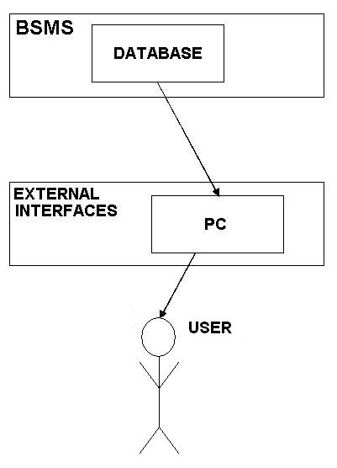

Functions of System Components :

1. Database :

  - Store data
  - Creates report
  - Provides PASSWORD protected access to data
  - Update information
- Server :

- Provides access to the database
- Authenticates user
- Processes entries
- Performs backups
- Produces reports
- Terminals :

- Users use terminals to access the server.
- The office authority uses terminals to admit students and to get information about the available rooms.
- Hostel administration may use terminals to see the reports generated by the database software.

2.2 Product Functions

This system provide a new view in hostel managing applications which will be used in monitoring predefined tasks.

- The proposed system maintains the details of the students required by the hostel.

- This proposed system will keep the track of the required information for student’s enrollment in the hostel. Thus, it helps user in efficient searching of information.

- System generates each student is allotted a Student ID in the format:-‘ course-course_year-room_no-(1/2)’

- It will keep in account the room allotment, that is, which room is allotted to which student.

- Room allotment is subdivided level of preference to course.

- The proposed system will also keep track of information for the fees section, that is, whether the fees is paid by the student or not.

- Number of semester students stays in hostel, each semester fees will be taken.

- Guest information is maintained, and guest payment is also managed, guest fees:- 30 Rs per day.

- Stores issue utilities, whose record is maintained.

- Issued utilities are retrieved and fine is collected is deposited late, at Rs5 per day.

- It will also hold information of student regarding the time limits, warnings, etc.

- The system will not allow any student to leave until his record is clear, like, fees paid, issued utility deposited, guest payment done.

- It also generates reports on useful information, like total fees deposited between any 2 dates, guest payment received, list of issued utilities.

- Scalable to expand later.

2.3 User Constraints

The main user of the system will be the attendant, assistant hostel warden, and warden for entering, manipulating, retrieving, and updating the entries.
Many areas where the superior authority like the Warden sir are only allowed to access, password protection is their.
The management administrates the access to the report generated by the system. The attendant which are the basic users are not required to have knowledge in the computer field.

The graphical interface provides an easy way of using the HMS system with minimum training.

2.4 General Constraints

- College fees receipt and admission slip must be shown original and photocopy must be submitted.

- Utilities are issued from 1 to 99 days only. So, the user should issue it according to the utility, like if sports utilities then not more than 5 days, toilet utilities can be issued for 30 days.. etc

- Registration date of a student cannot be earlier than 4/20/2009(mm/dd/yyyy).

- Date of birth will lie in range 1/1/1980 to 12/31/1992

- Guest payment will be always Rs30 per day.

- Fine on late return of utility is fixed at Rs5 per day.

- Guardian address and contact & 2 photographs of student must be submitted.

- One room will be allotted to 2 students only.

- There are total 40 room in hostel 20 rooms in A block, and 20 in B block.

2.5 Assumptions and Dependencies

  - Sports utilities issued should be timely deposited.

  - Only one bed, a table and chair will be allotted to individual student. Used utilities should be deposited as it is.

  - Each individual is responsible for his belongings.

  - Bedding will not be provided.

  - Drugs, liquor, smoking are banned in the hostel campus.

  - Students must provide their own study lamps with electric bulb of not more than 60watt power.

3. Functional Requirements

Users security and access component :

This component is responsible for providing a user name and password for the access of simple API (Application Program Interface) of the software interface.

3.1 Usecase Diagram

4. External Interface Requirements

4.1 User Interface

The product is a graphical user interface, so user, attendant or the office authority interacts with the terminal and makes input and output with corresponding devices.

- Graphical :

The whole project deals with the user with a graphic user interface, which is being designed at windows based Visual Basic. Due to GUI it is user friendly, and helps in checking the layout of receipts or data report, which are to be generated.

- Command Lines :

As it is GUI and there is no need to enter any command lines, for any function to be performed just a click on buttons, which will call the required function. So no command line functions are used which will make it easy to train and use.

- Application Program :

The projects is designed by keeping in mind the requirement of the corresponding hostel so all functions are build in and user’s are not involved in development of any application program. This has reduced the complexity to a large extent.

5. Performance Requirements

- Should run on 256 MB of RAM.
- 95% of the responses should be within 2 seconds.
- As the interacting front hand is build on Visual Basic which is windows based. So it can perform only on windows operating system.

6. Design Constraints

This software will work efficiently on a machine having minimum of 20 GB storage and 256 MB Ram. This software will not run on Macintosh based machine or a mobile platform . Like other major projects this software does not support any touch screen feature or wireless feature.

6.1 Standard Compliances

Software requirements for proposed system are:-
Microsoft Windows 2000 Advanced Server Edition

Number | Description | Alternatives  ( If available)
1 | Visual Basic 6 | VB.NET
2 | MS Access | Oracle

6.2 Hardware Limitations

- Intel Pentium III 1.5 GHz.(Pentium IV 2.4 MHz. recommended)
- 256 MB RAM
- 40 GB Hard Disk Drive
- 15” Color Monitor
- 52X CD Drive
- UPS
- Compatible Keyboard
- Mouse
- Printer
- Other Standard Components

6.3 Platform limitations

As the interacting front hand is build on Visual Basic which is windows based. So it can perform only on windows operating system

7. Attributes

- Security:
As login name and passwords are used at login time so security is maintained. Some functions are to be kept under control of some specific authority so password protected entry is used.

- Binary Compatibility :
Our software makes it possible to extend an existing class or interface by adding new methods and properties and yet still retain binary compatibility.

- Reliability :
As tables are used for storing the data, so reliability is maintained as exact data is retrieved. Data is regained from each table by using a unique key so the accurate record is accessed.

- Maintainability :

Maintenance usually comprises of 2 key factors:-

  - Updation :-
As the project is build with keeping in mind all the necessary functions so no essential updation is required. VB can be updated so that new layouts of data reports can be produced as desired.

  - Terminals must be updated with antivirus so the proper functioning of operating system can be maintained.

- Portability :
As the size of project code is enormous. So a CD can be used to transfer it from one server to other. If required then data can also be moved using secondary memory devices. So it is portable to a large extent.

- Extensibility :
The project is easily extensible as VB support further editing, such as adding new functions, new forms or editing old forms.

- Reusability :
The extensibility and portability of this project would make it reusable software.

- Application Affinity :

- Resource Utilization :

- Serviceability :

This project will try to provide maximum possible service to the user.

